Data Lake

DemoStore

Financial version



Index

Data Lake Workshop 2

Ingestion, Processing and Query Data 2

Deploy Solution and Demo 4

Deploy Ingestion and Processing template 4

Amazon Kinesis exploration 5

Start Kinesis analytics applications 7

Explore the SQL code in Kinesis Analytics 9

Check the Streaming data sample 10

Check the Anomalies and Aggregated results 11

Explore to the Destination Tab to Kinesis Firehose 12

Verify Amazon S3 console and what is in the bucket 13

Check CloudWatch Dashboard 15

Configurate Kibana 17

Open Management to create an Index 18

Import a Dashboard for Bank transactions 20

Access the Dashboard for Bank transactions 22

Working with your Data Lake 24

Crawler the S3 to pick table definition on Glue 24

Query Data in Amazon Athena 25

Adjust Column names on Glue for aggregated Data 28

Query aggregated data table in Amazon Athena 30

Visualize Data with Amazon Quicksight 31

Setup permissions to access Athena and S3 32

Create a Data Source 33

(OPTIONAL) Tranforming Data – Amazon Glue 38

Create a Tranforming Job in Glue 39

Crawler the S3 to pick table the new table definition on Glue 42

Go to Athena to query the Optimized Table you created 43

# Data Lake Workshop

This Workshop is a practice experience of AWS platform to build and use a Data Lake in a test account. Although you can deploy the same Cloud Formations to your own account.



# Ingestion, Processing and Query Data

To Simulate a real world ingestion we have created a Cloudformation to ingest data to be processed and analyzed.

The process start with a Lambda function that generates random payloads to a Kinesis Streams.

The Kinesis Streams is consumed by 3 different consumers, Kinesis Firehose, Kinesis Data Analytics and a Lambda Function, so for each payload we have 3 destinations.

The Kinesis Data Analytics plays a real time aggregation and/or analysis of the streaming, Kinesis Firehose put exact the raw data into an S3 bucket to be analyzed latter.

Elastic Search is ingested by a Lambda Function and give us a realtime visualization with Kibana.

# Deploy Solution and Demo

**Make sure you are in N.Virginia Region:**

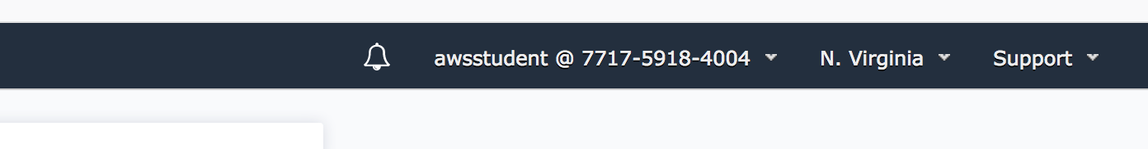

You can Change region if it’s not N.Virginia.

## Deploy Ingestion and Processing template

Click on the link to launch the cloudformation :

<https://console.aws.amazon.com/cloudformation/home?region=us-east-1#/stacks/new?&templateURL=https:%2F%2Fs3.amazonaws.com%2Fawsdemostorecdf-useast1%2Finitial-conf-template%2Ffinancial.template>

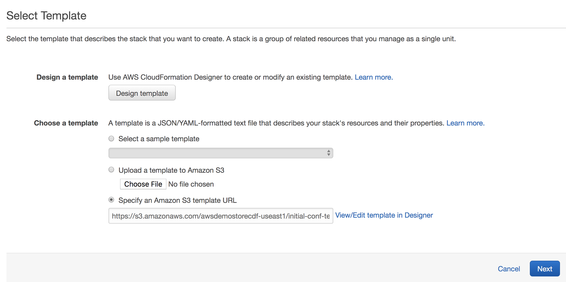

Don’t change anything in this screen.

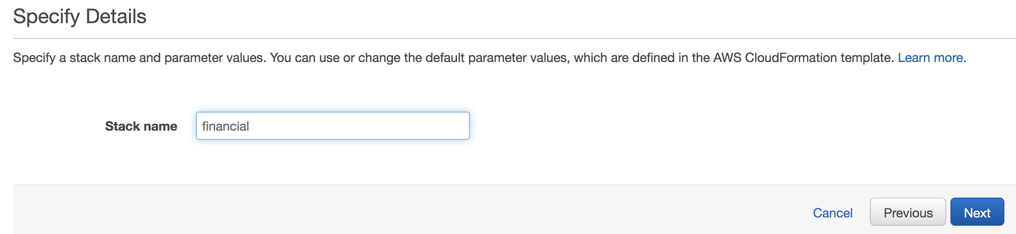

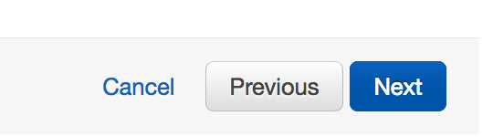

**Next -> Next - > Check IAM and Create template**

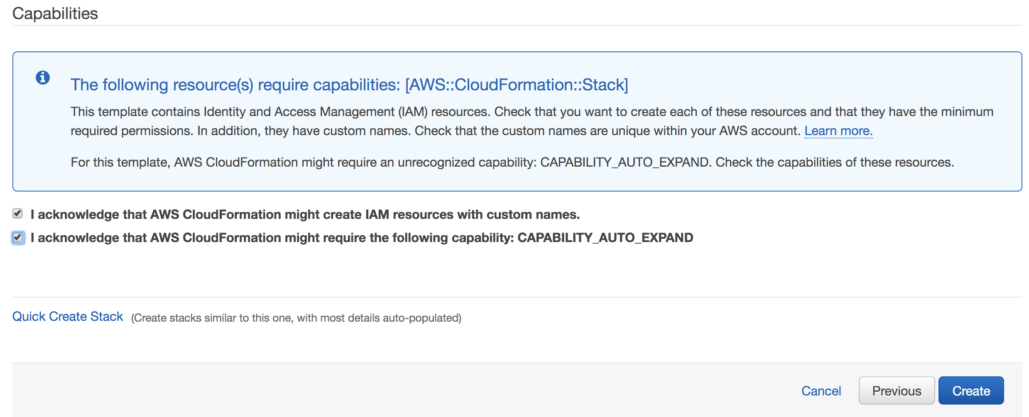

Go to Cloudformation console:

[https://console.aws.amazon.com/cloudformation/home?region=us-east-1#/stacks](https://console.aws.amazon.com/cloudformation/home?region=us-east-1#/stacks?filter=active)

Explore the resources created:

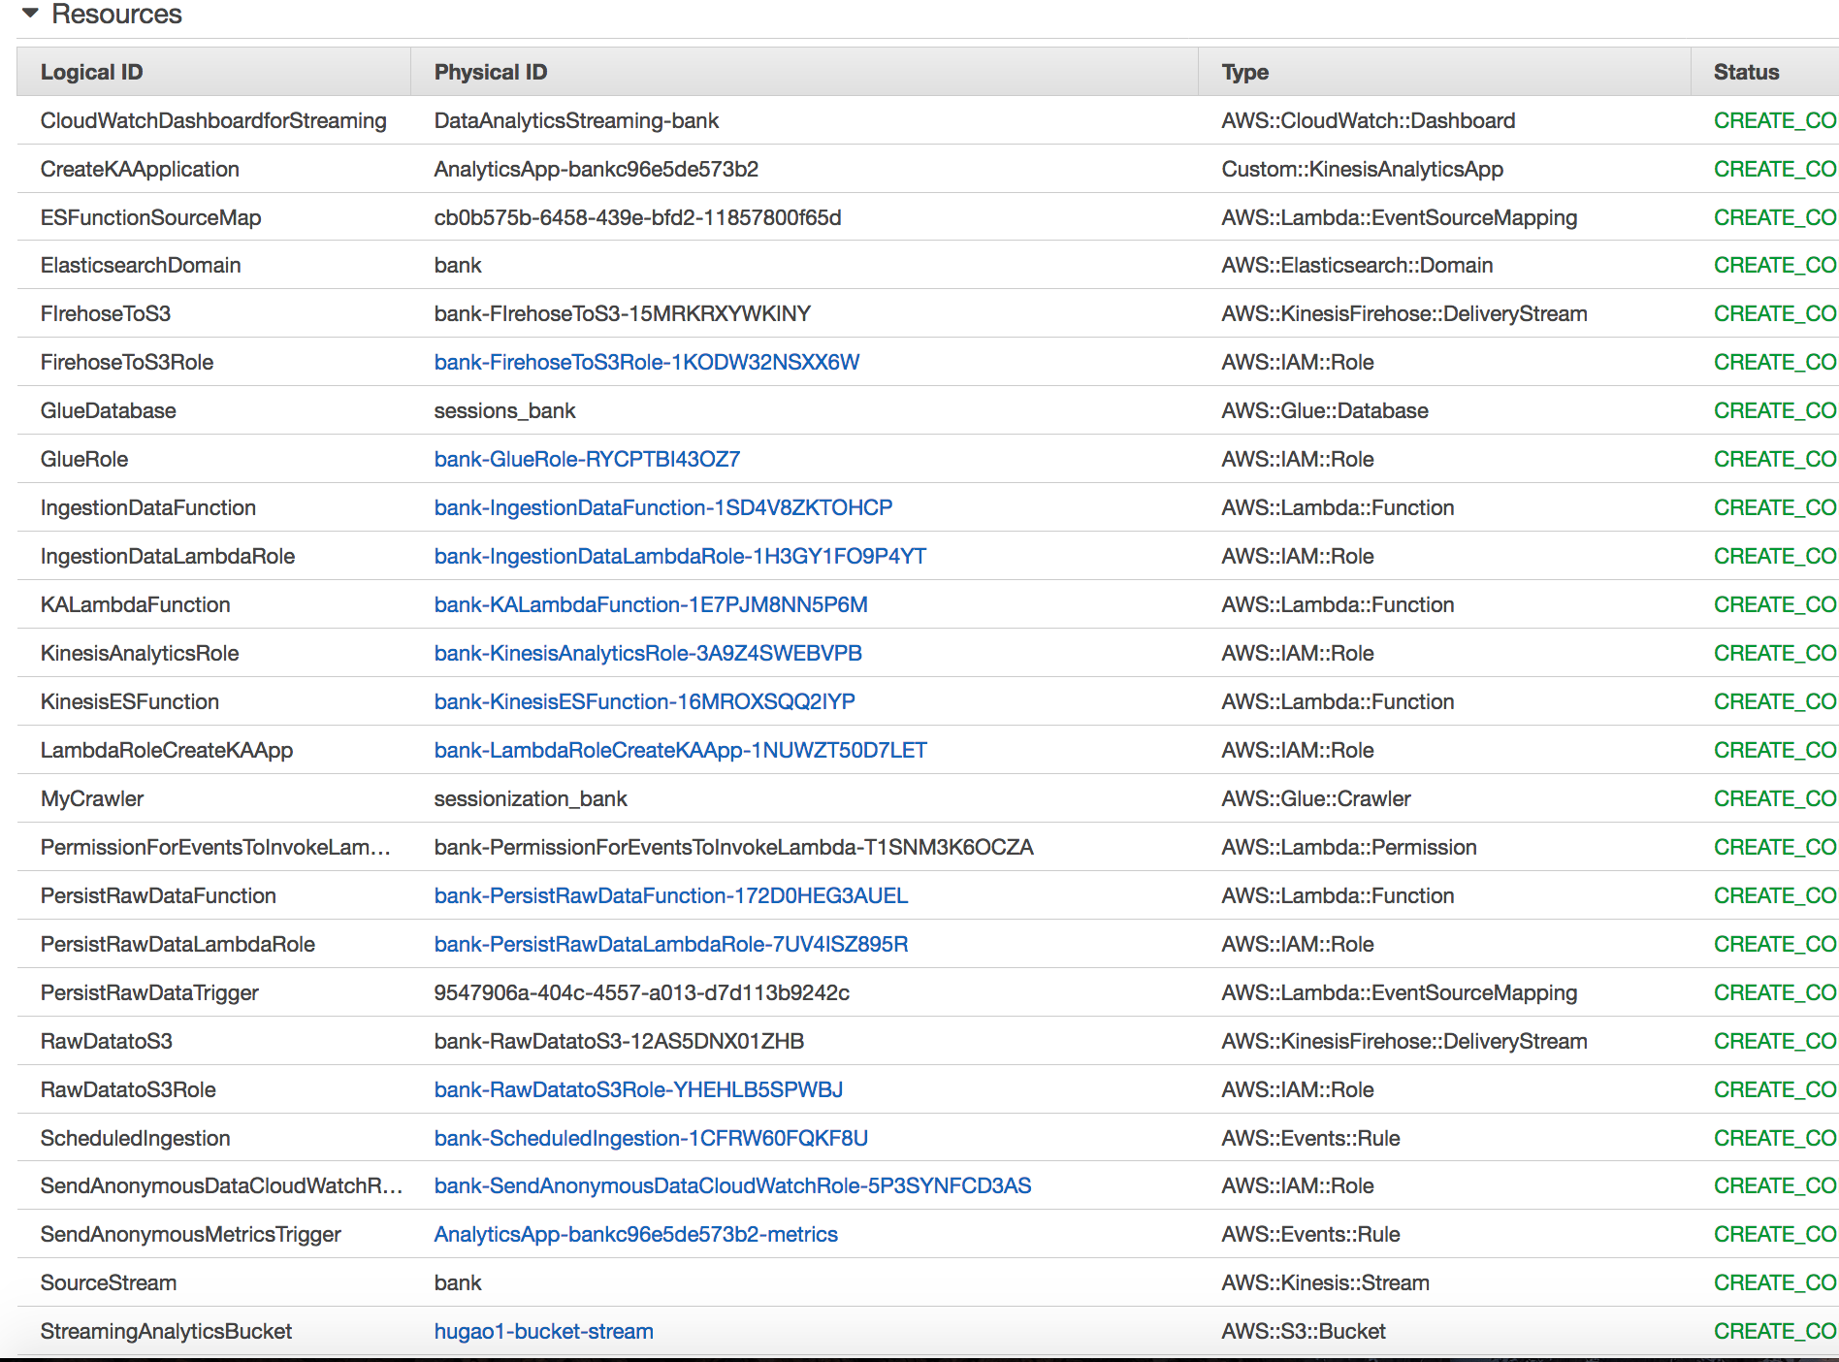

### Amazon Kinesis exploration



Go to Kinesis console:

<https://console.aws.amazon.com/kinesis/home?region=us-east-1#/dashboard>

Explore Kinesis data streams and

Kinesis Firehose.

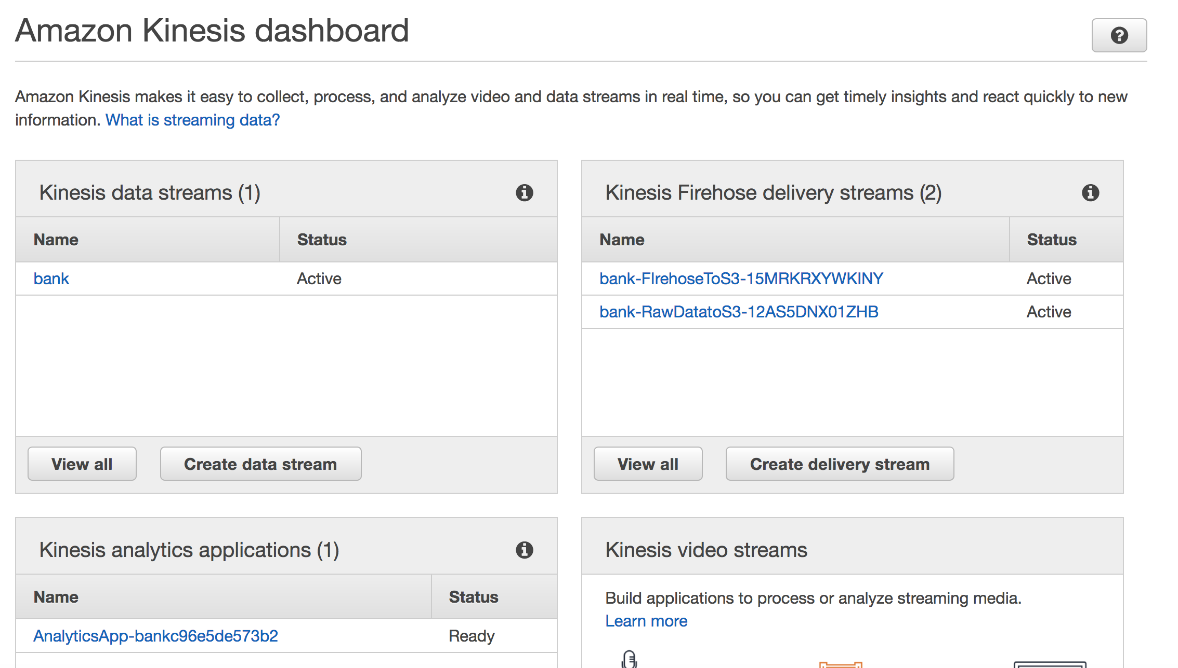



### Start Kinesis analytics applications

<https://console.aws.amazon.com/kinesisanalytics/home?region=us-east-1#/>

Select and open Application Details

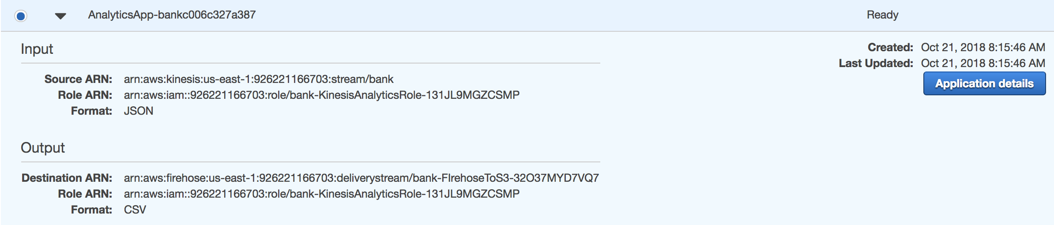

Open the Application and go to “Go to SQL editor” button and Start Application

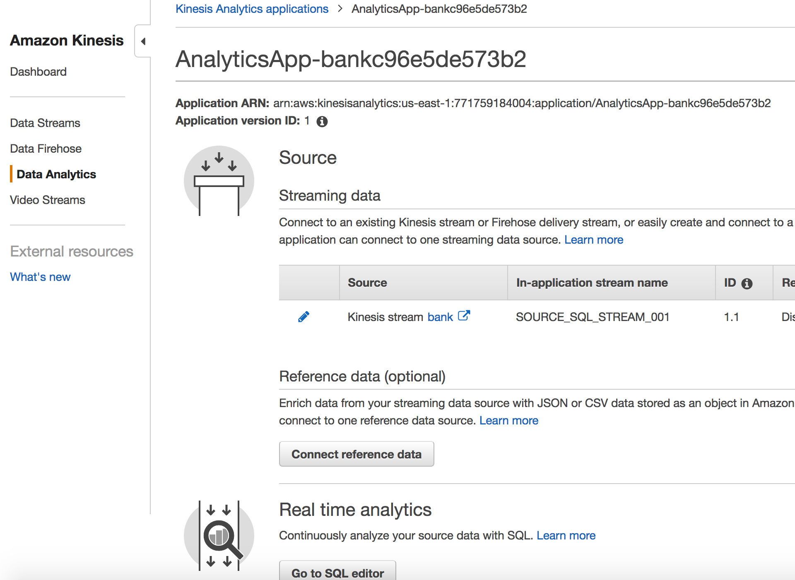

Click on Go to SQL editor and Start the application, click “Yes, start application”

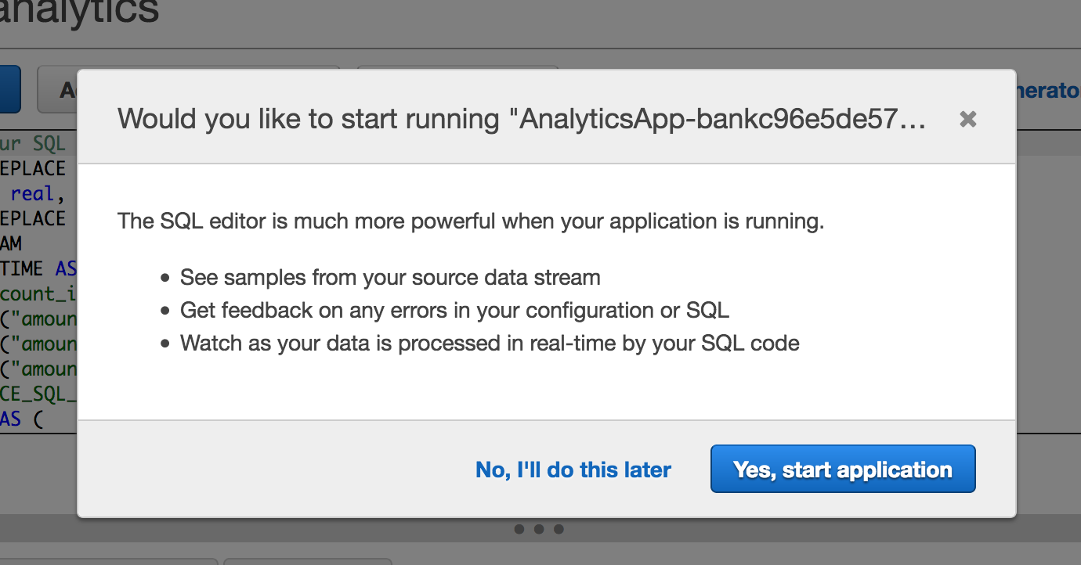



### Explore the SQL code in Kinesis Analytics

Explore the SQL code :

For aggregate metrics for every Account_id:



The above code setup a streaming “table” DESTINATION_SQL_STREAM to receive aggregated data from 1 hour interval.

The code bellow calculate the MIN, MAX and AVG transactions amount for each Account_ID:

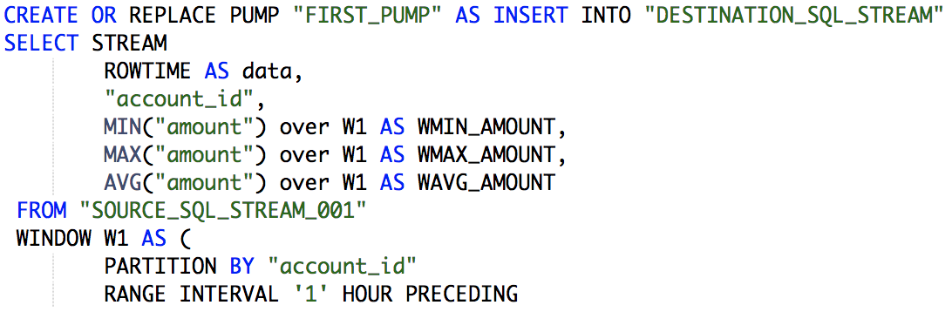

For Anomaly detection :



The above code setup a streaming “table” ANOMALIAS to receive anomalies detected in transaction behavior

The code bellow estimate anomalies based on Random Cut Forest algorithm with explation and ingest the result for #Anomalies Score above 90% to the “table”

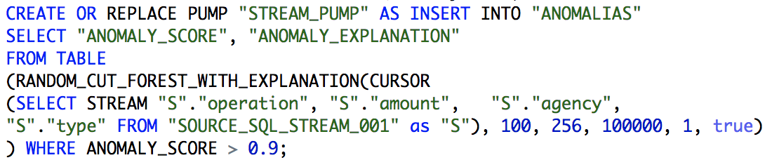

### Check the Streaming data sample

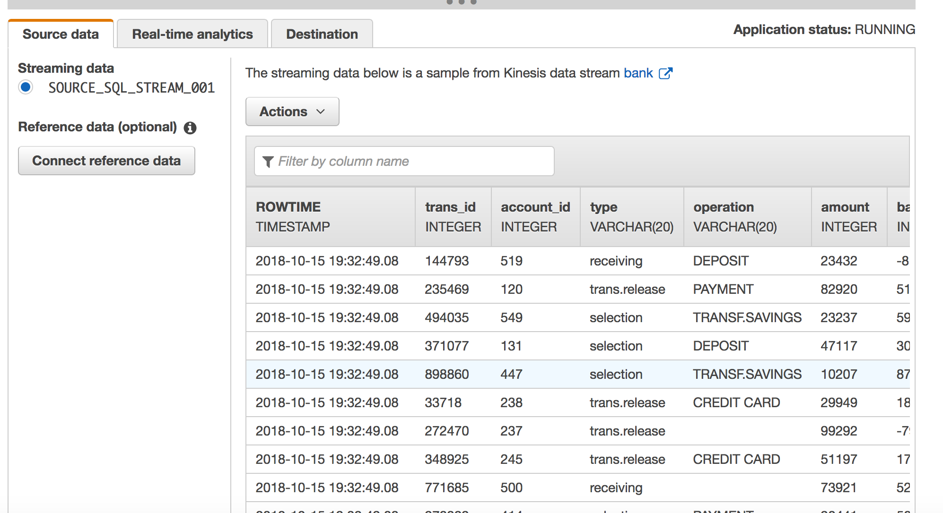

Navigate in the sample :

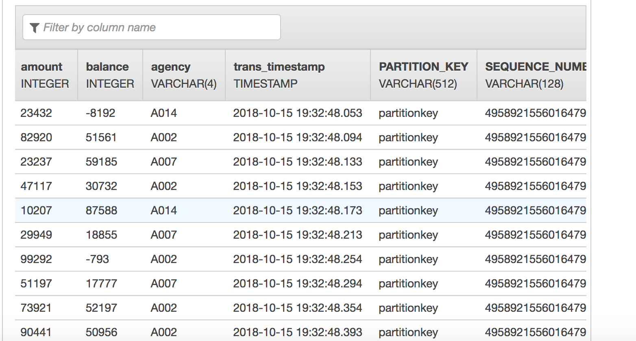

### Check the Anomalies and Aggregated results

Click on real-time analytics and check Anomalias:

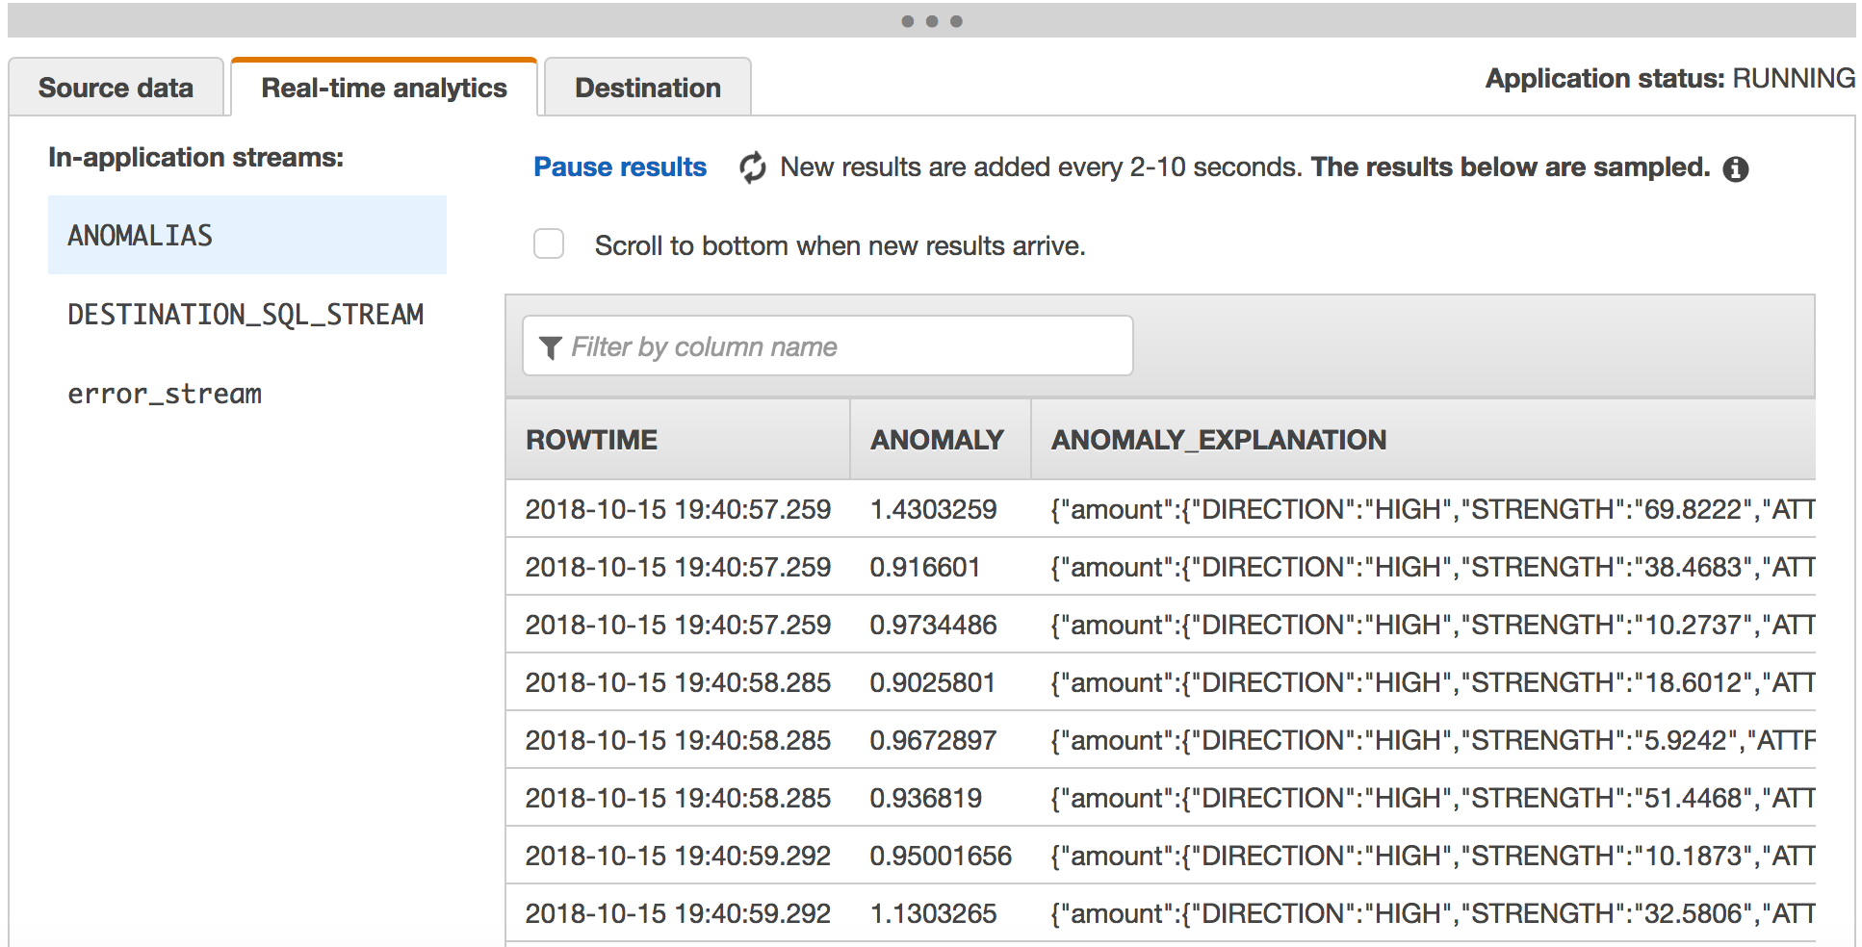

Click on real-time analytics and DESTINATION_SQL_STREAM:

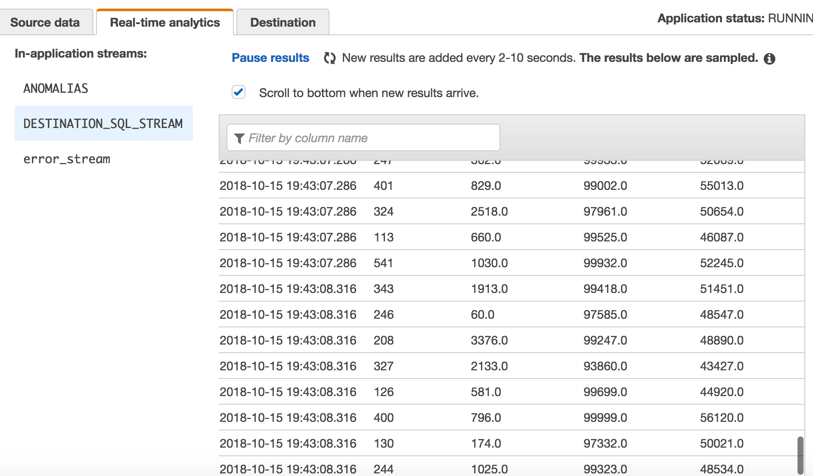

### Explore to the Destination Tab to Kinesis Firehose

Check the kinesis firehose destination setup to put the aggregated data in S3 :

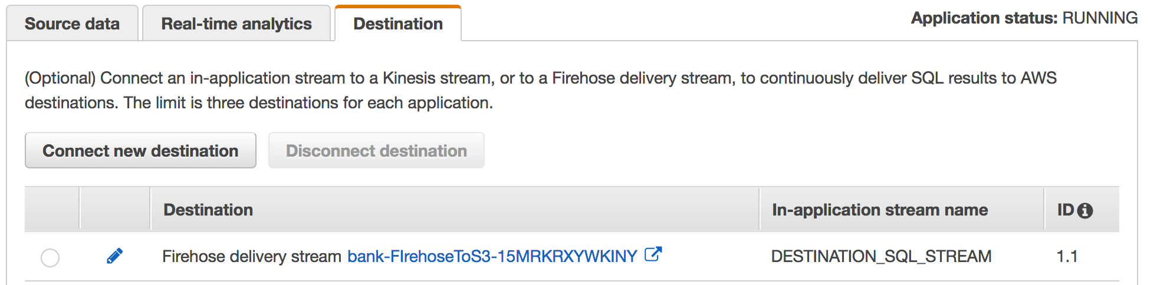

Click the FirehoseToS3 link :

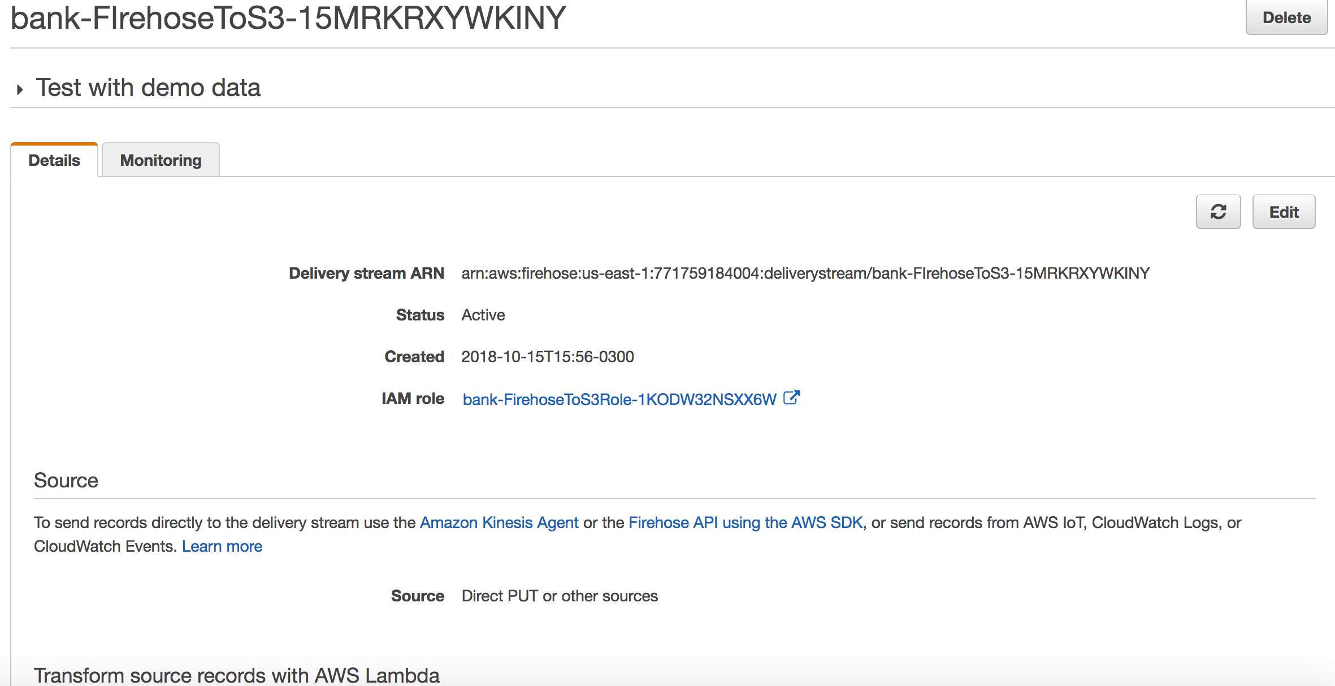



### Verify Amazon S3 console and what is in the bucket

<https://console.aws.amazon.com/s3/home?region=us-east-1>

Click in your bucket name and see two folders “raw” and “aggregated”.

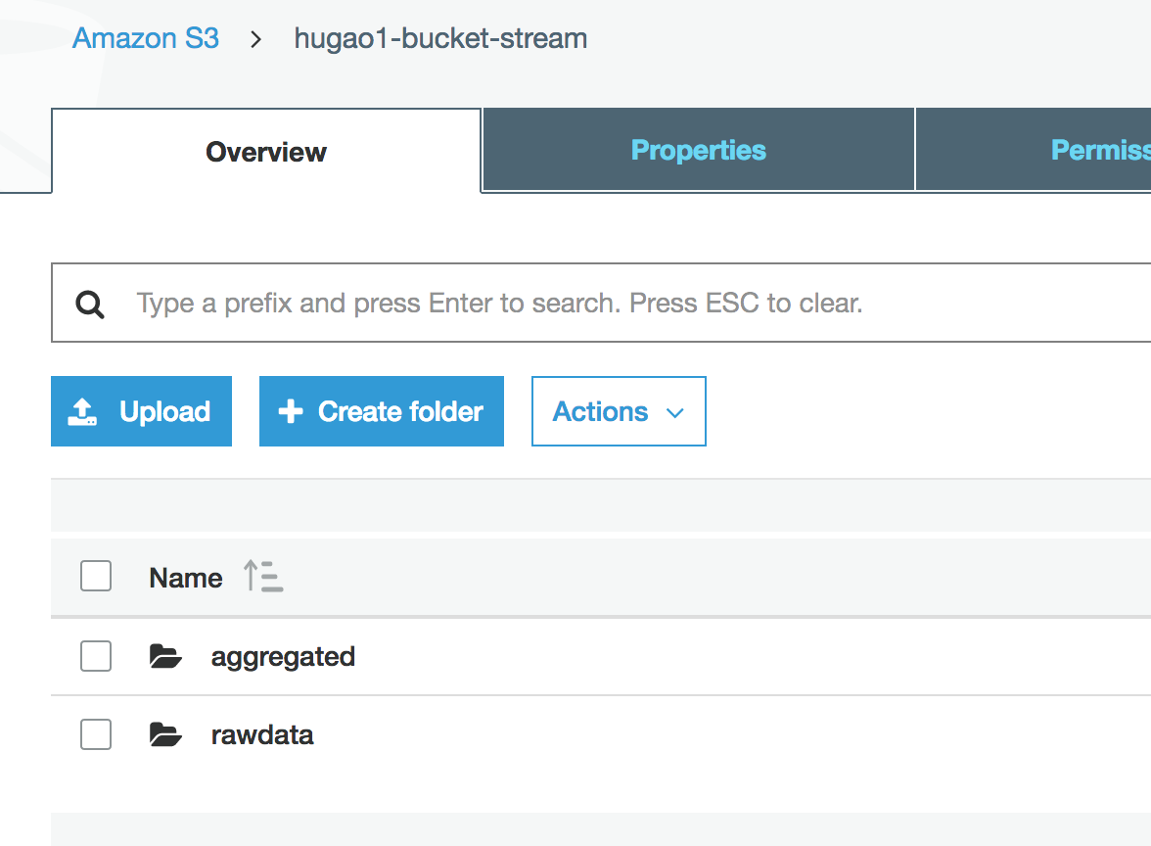



Navigate through the folders and check the files.

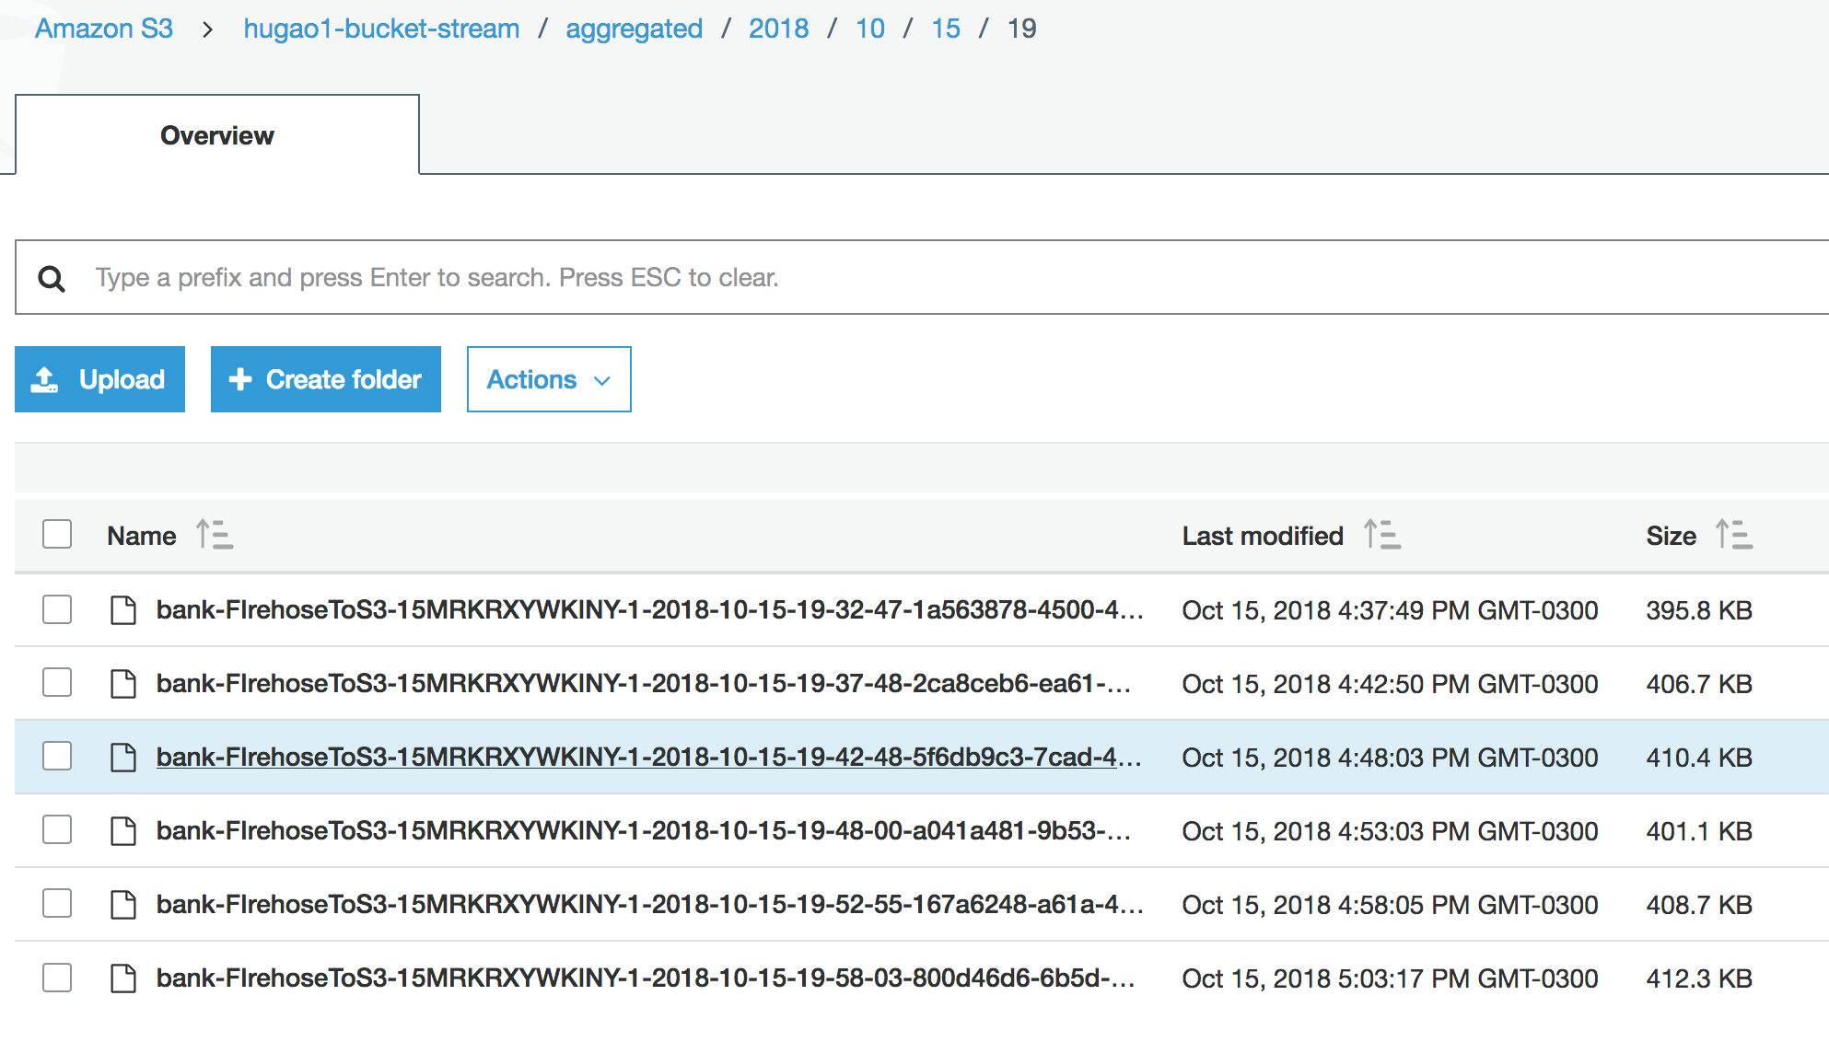

### Check CloudWatch Dashboard

<https://console.aws.amazon.com/cloudwatch/home?region=us-east-1#dashboards:name=DataAnalyticsStreaming-bank>



View ingestion metrics calculated.

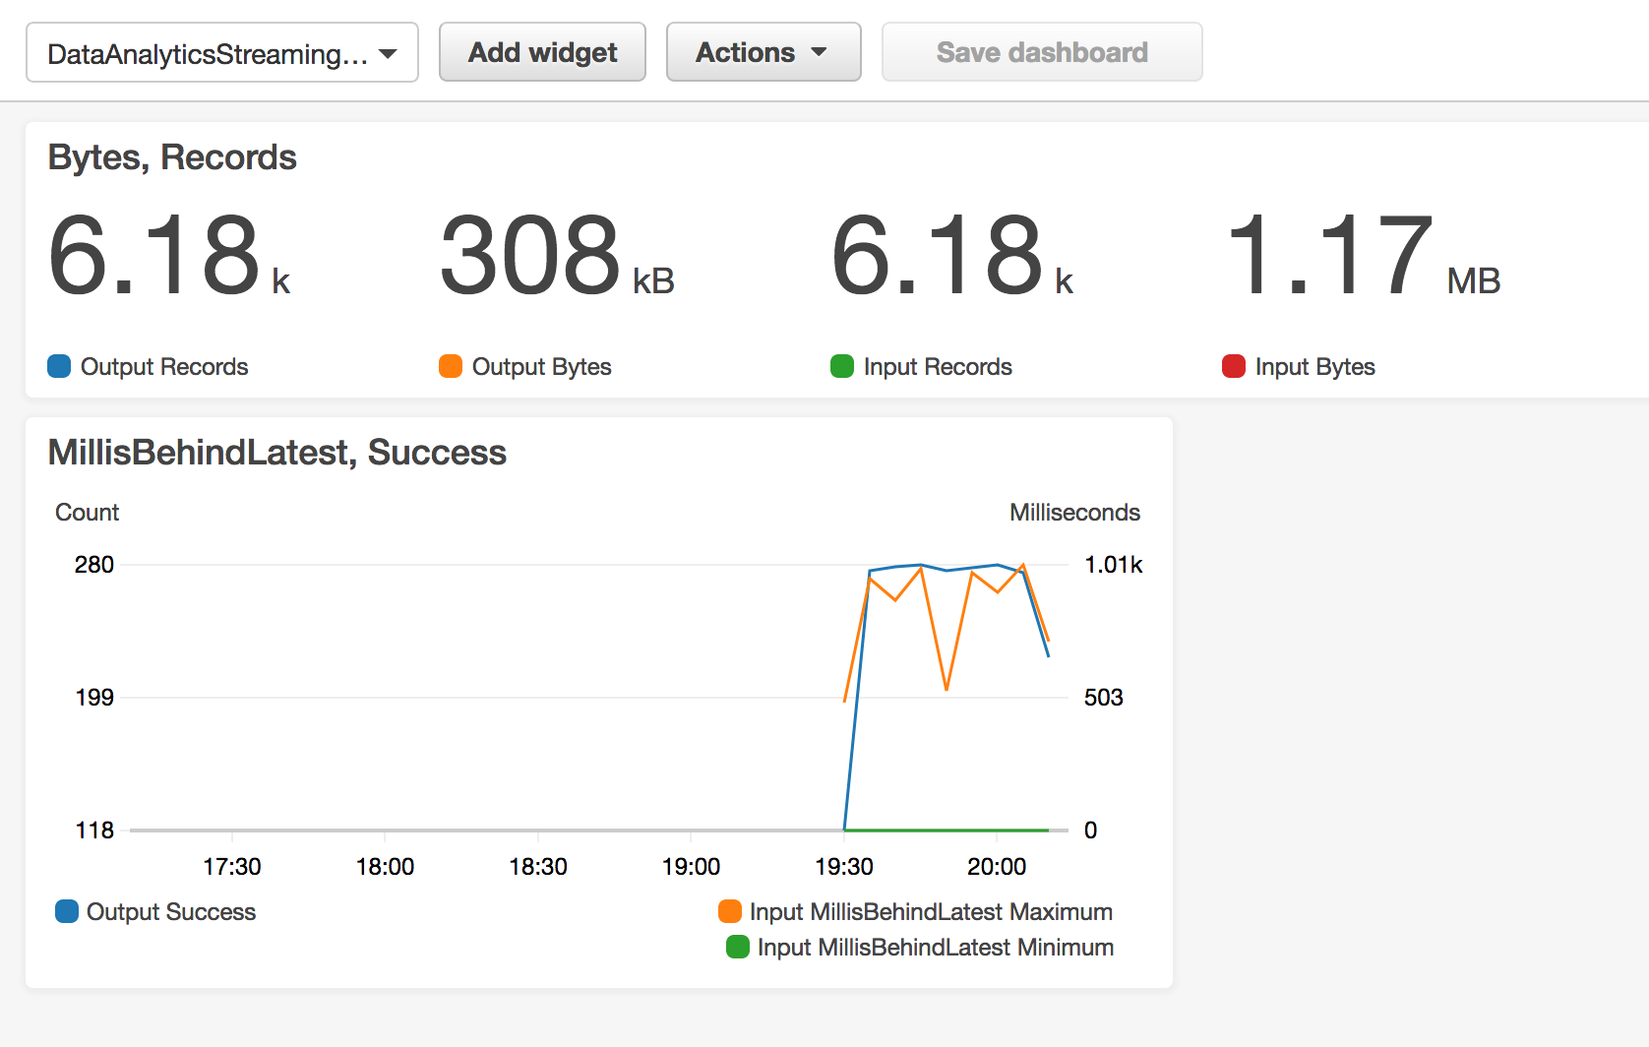

## Configurate Kibana

Go to Elasticsearch Dashboard.

[https://console.aws.amazon.com/es/home?region=us-east-1#](https://console.aws.amazon.com/es/home?region=us-east-1)



Click on Bank elasticSearch .

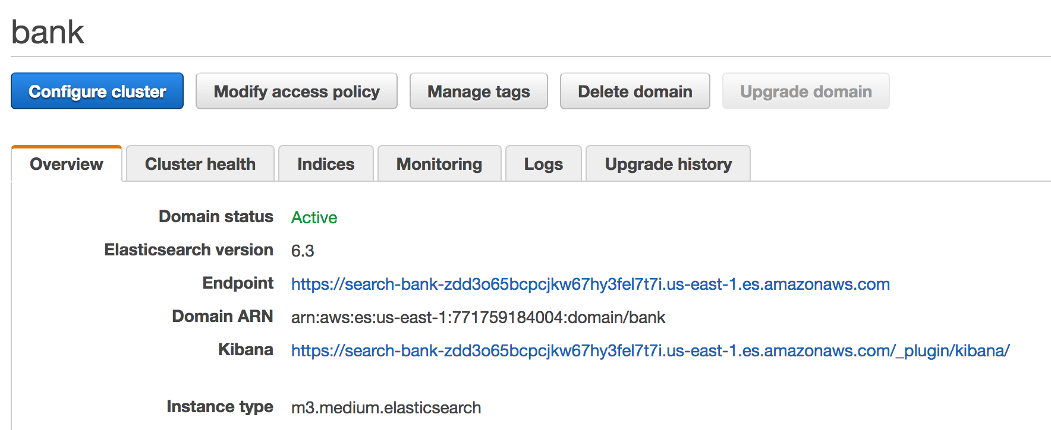

Click on **Kibana** link !

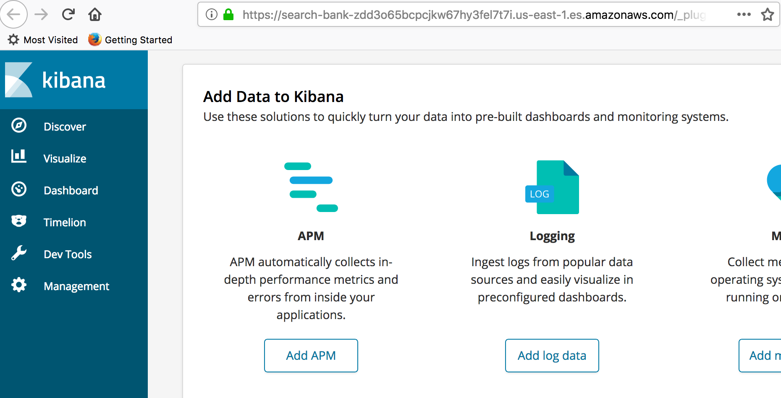

### Open Management to create an Index

The management option permits you to configure an Index.

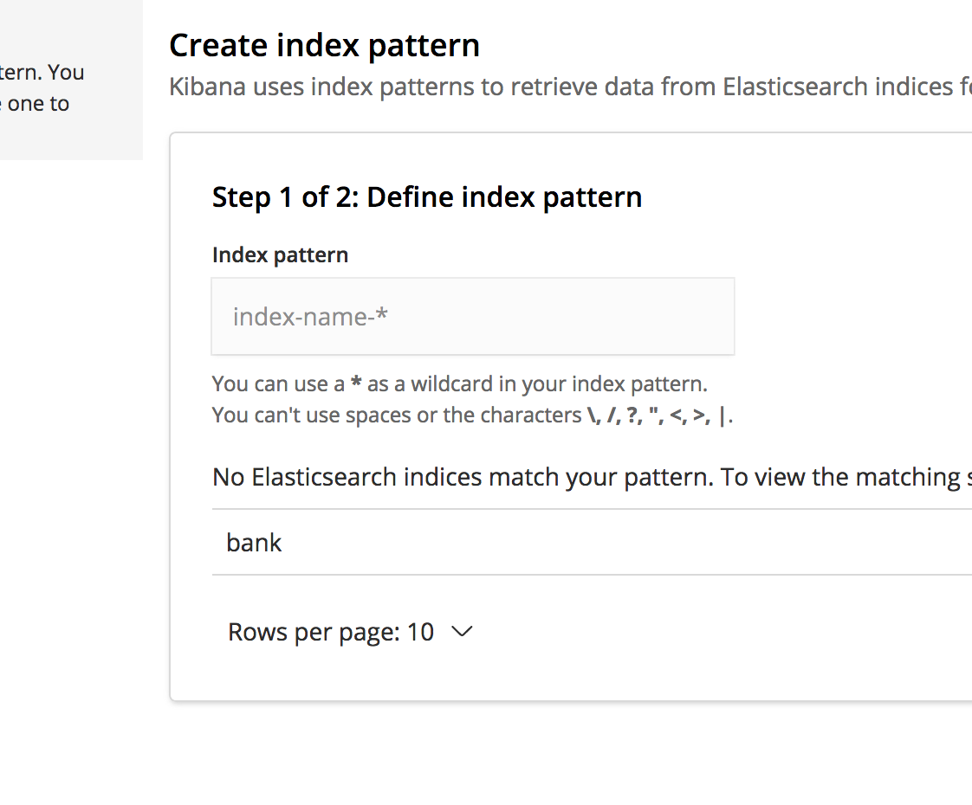

Write : **bank** in the Index Pattern

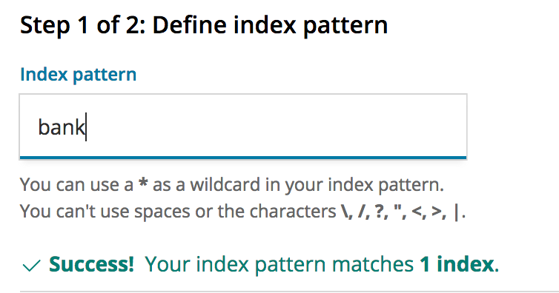

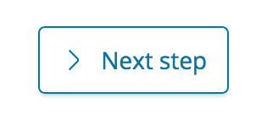

Select trans_timestamp as the time field for this index.

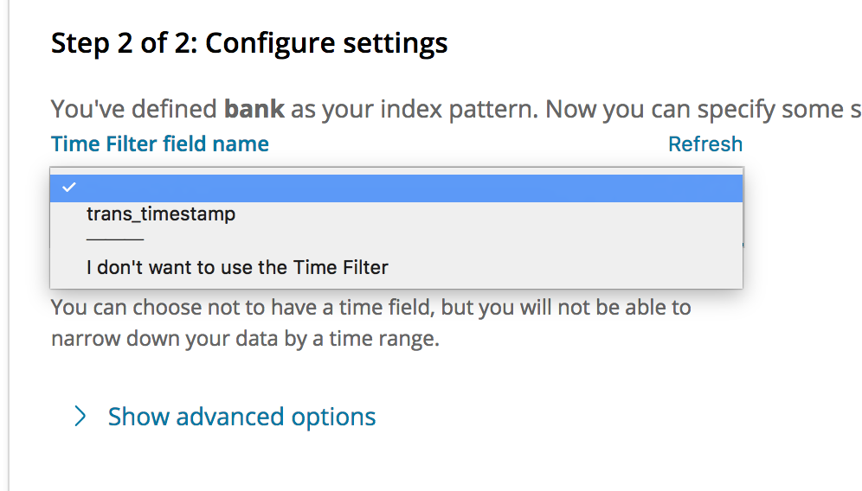

And Create the index pattern

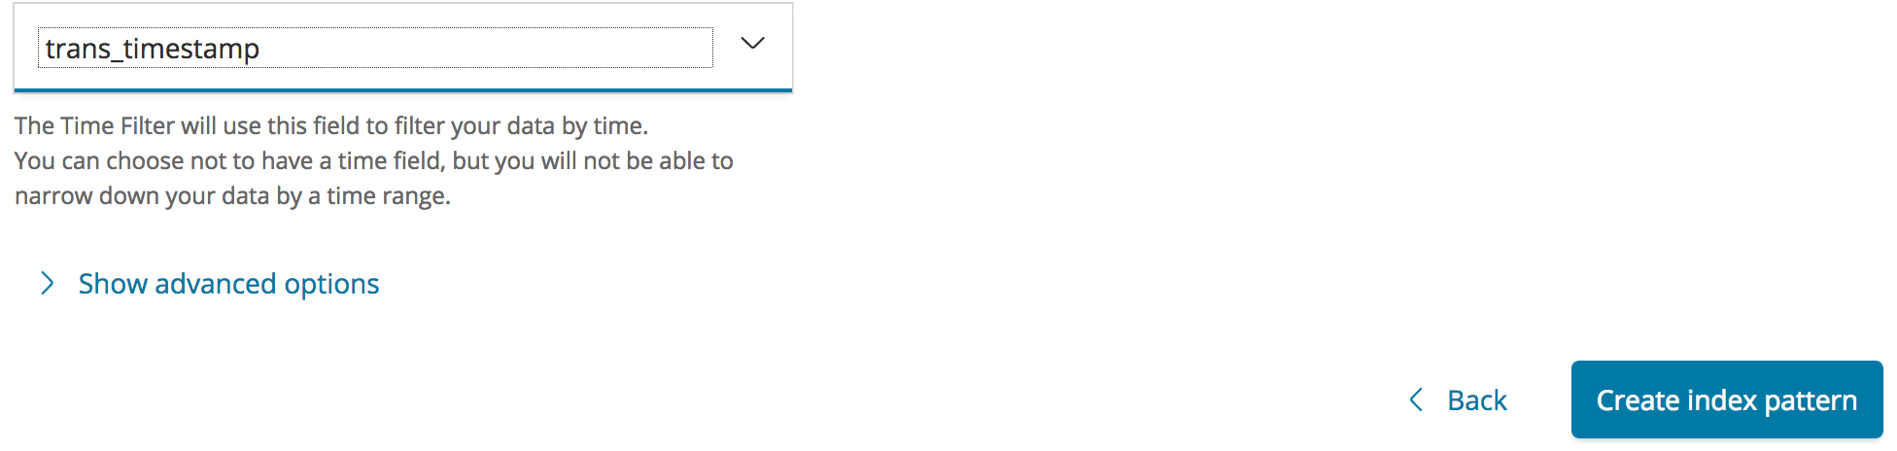

As a result you should see this:

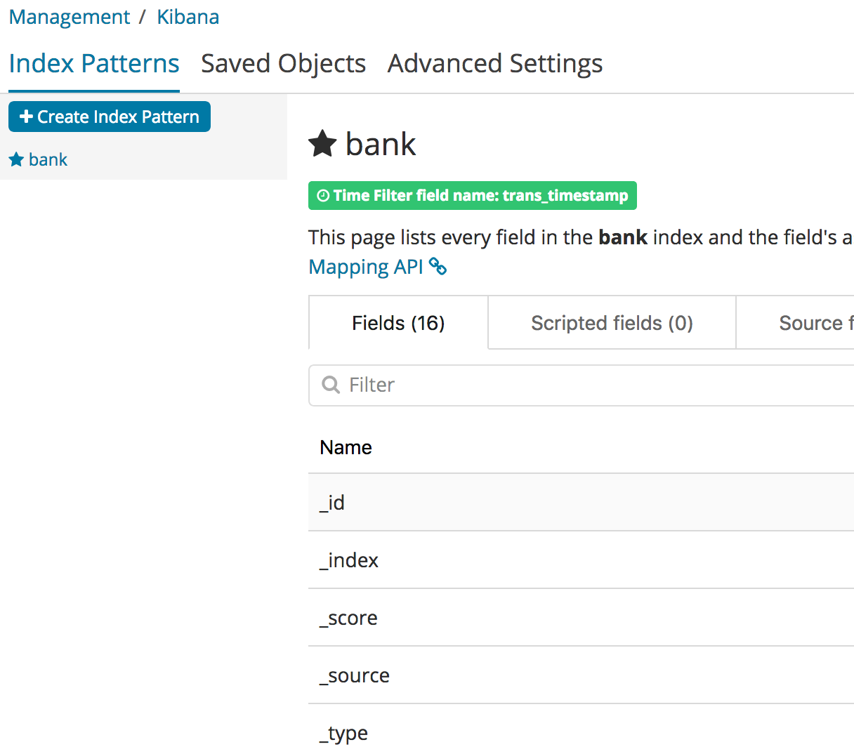

### Import a Dashboard for Bank transactions

Go to the file in S3 :

<https://s3.amazonaws.com/hhug-demo-data/kinesis-demo/bank/kibana_visual.json>

**Open in your Brower and Save AS local file :** kibana_visual.json file in your computer

**­­­**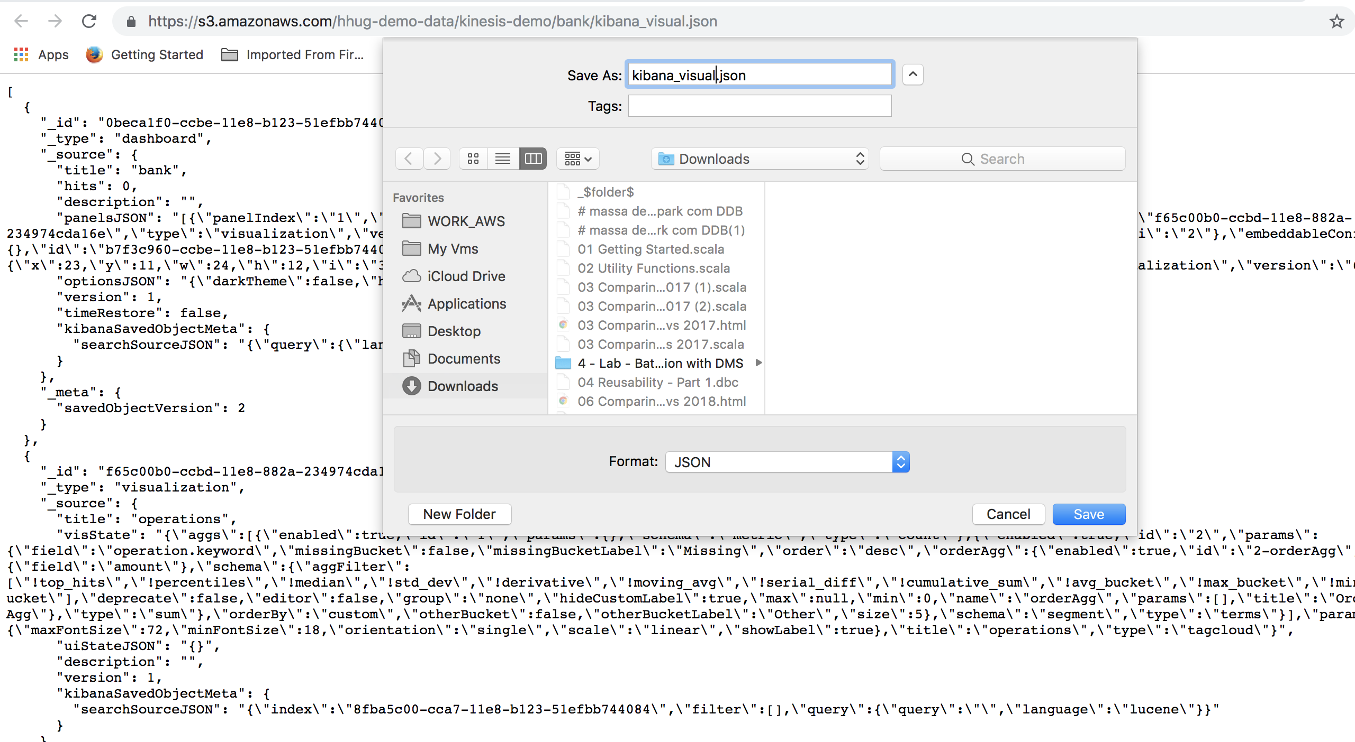

In Kibana web UI go to Management -> Saved Objects

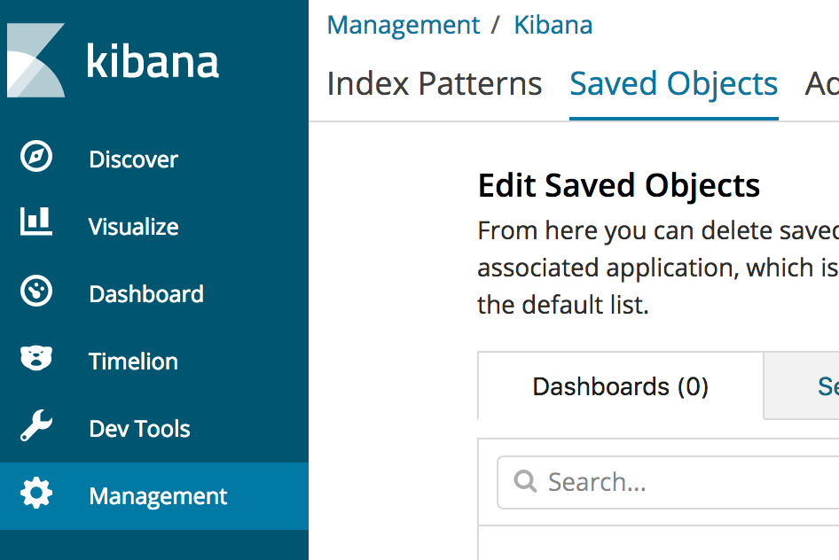

**At the top Right click on Import :**

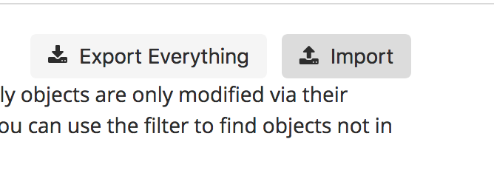

**Select the file you have downloaded :**

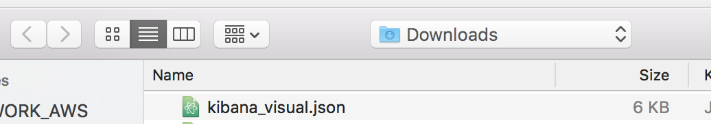

**Select OverWrite**

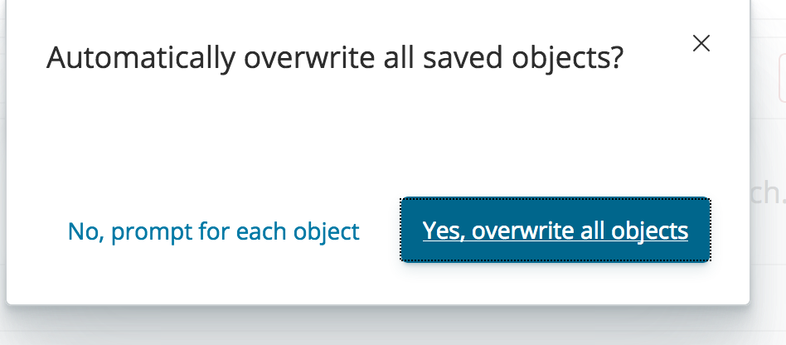

**Confirm All Changes**

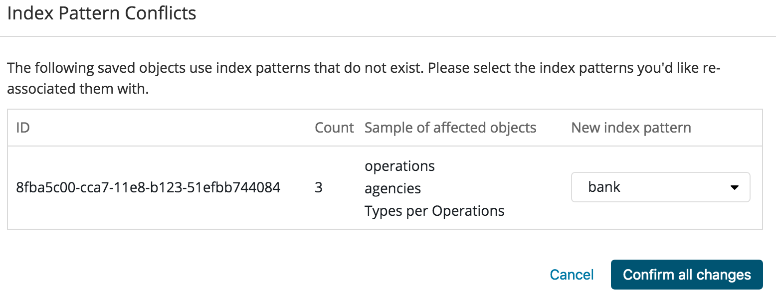

### Access the Dashboard for Bank transactions

Go to the Dashboard menu and click on **bank**

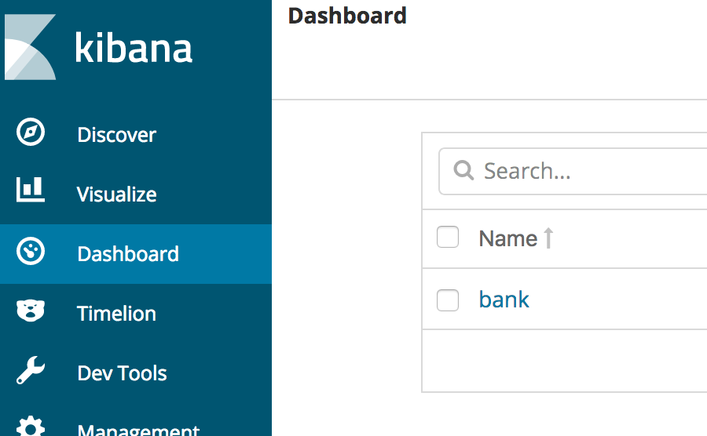

Change the window time to **Last 4 hours** to adjust the Timezone .

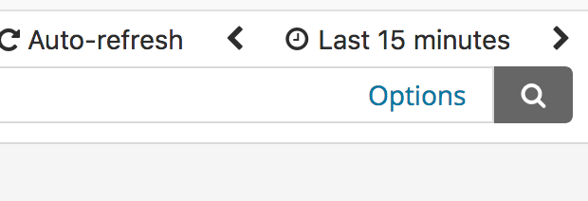

Change it to 4 hours :

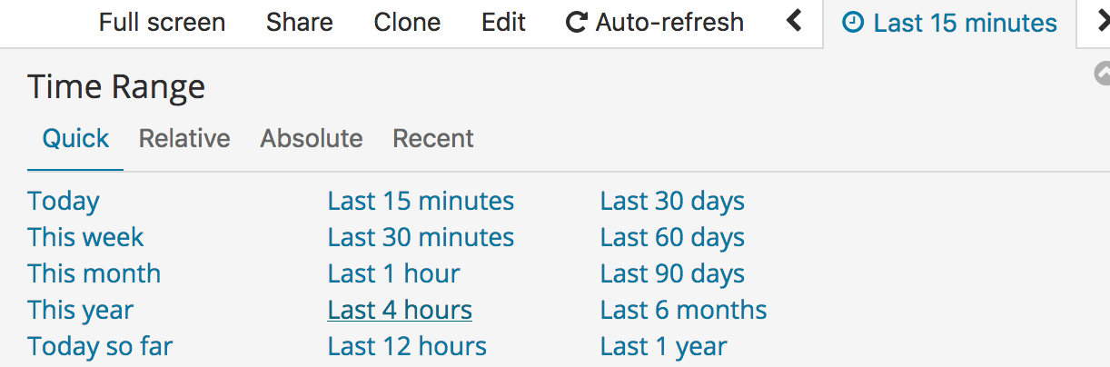

You should have this dashboard:

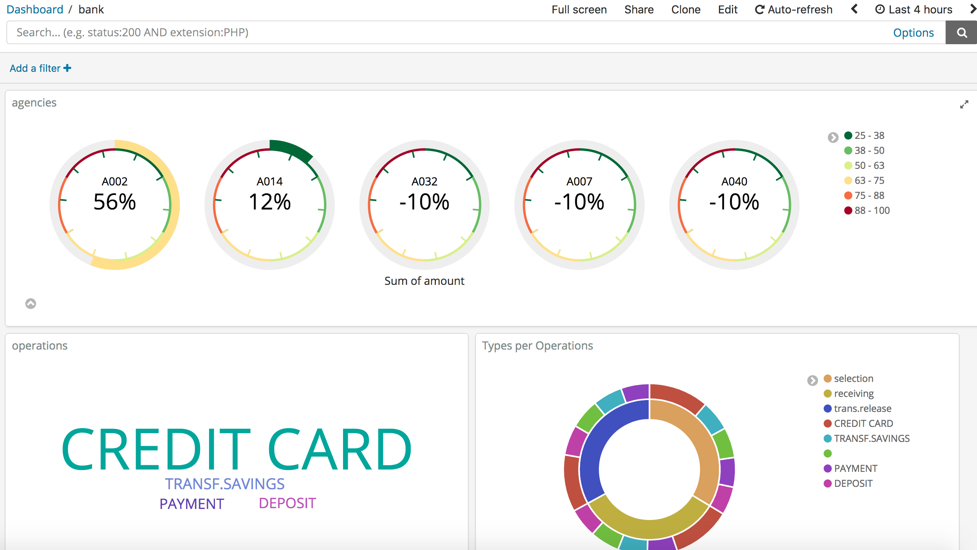

## 

# Working with your Data Lake



## Crawler the S3 to pick table definition on Glue

<https://console.aws.amazon.com/glue/home?region=us-east-1#catalog:tab=crawlers>

Go to the Glue menu and click on Crawler, choose **sessionization_bank.**

Mark the job and click **Run crawler.**

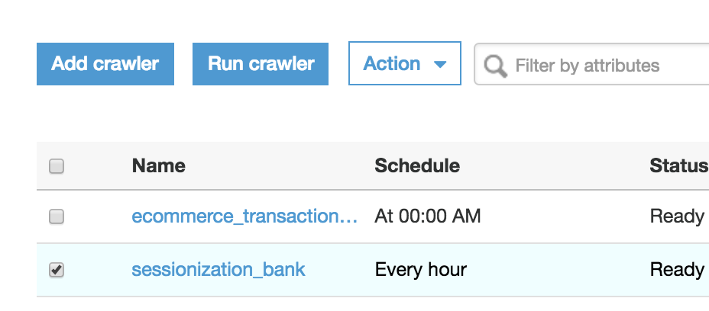

After the completion of the job you should see:

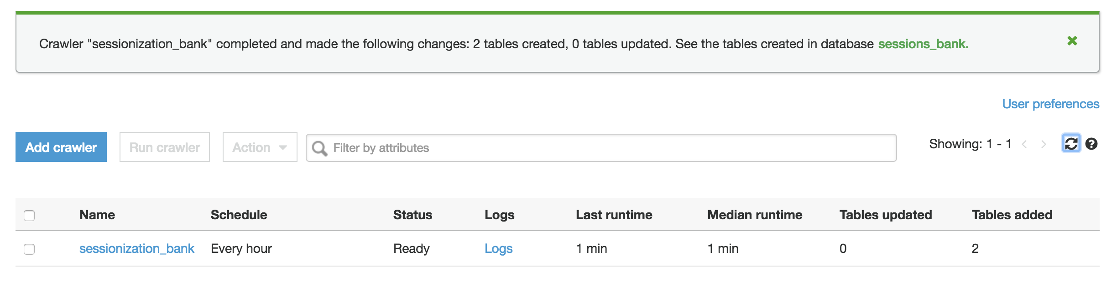

## Query Data in Amazon Athena



<https://console.aws.amazon.com/athena/home?region=us-east-1#query>

Go to the Athena menu and click on Databases, choose **sessions_bank_ .**

Click on Get Started. Then click ( x ) to exit tutorial .

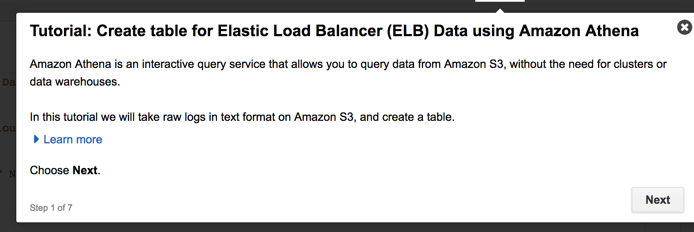

Choose database session_bank:

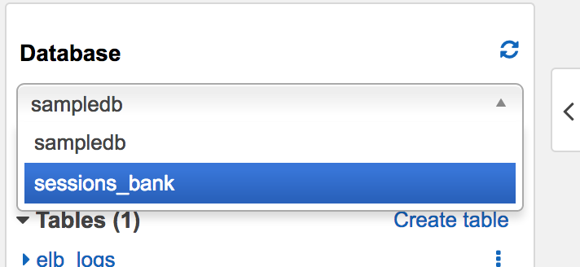

**You should see two tables :**

Right-Click on rawdata table and Preview.

To check table data.

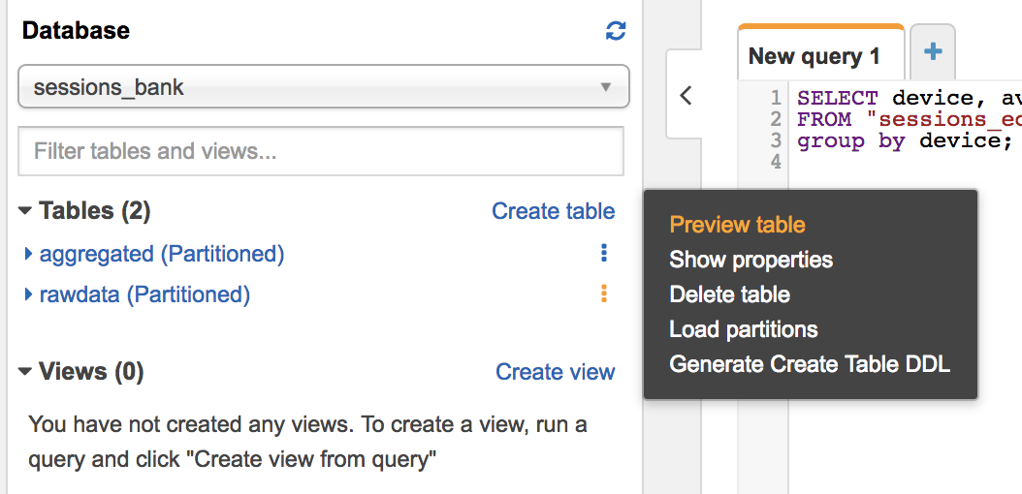

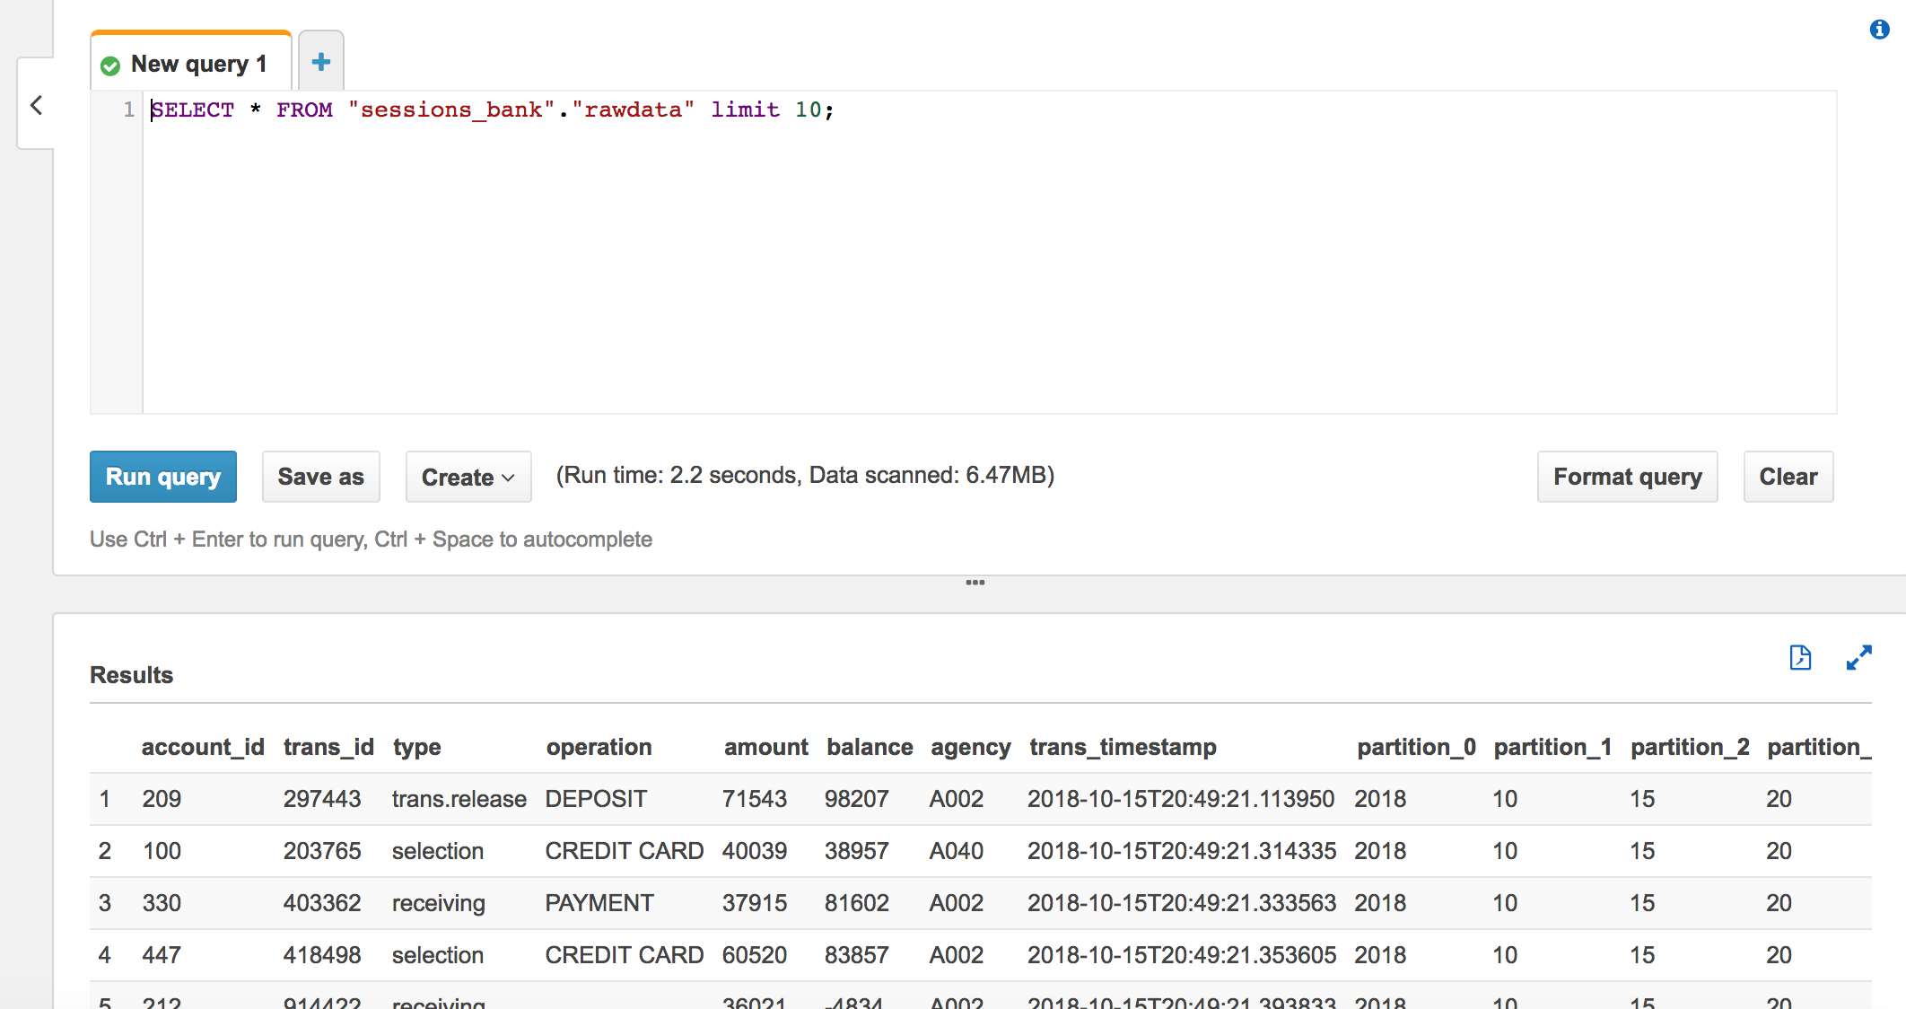

Explore the operation performed the most.

SQL

SELECT operation, sum(amount) total

FROM "sessions_bank"."rawdata"

group by operation;

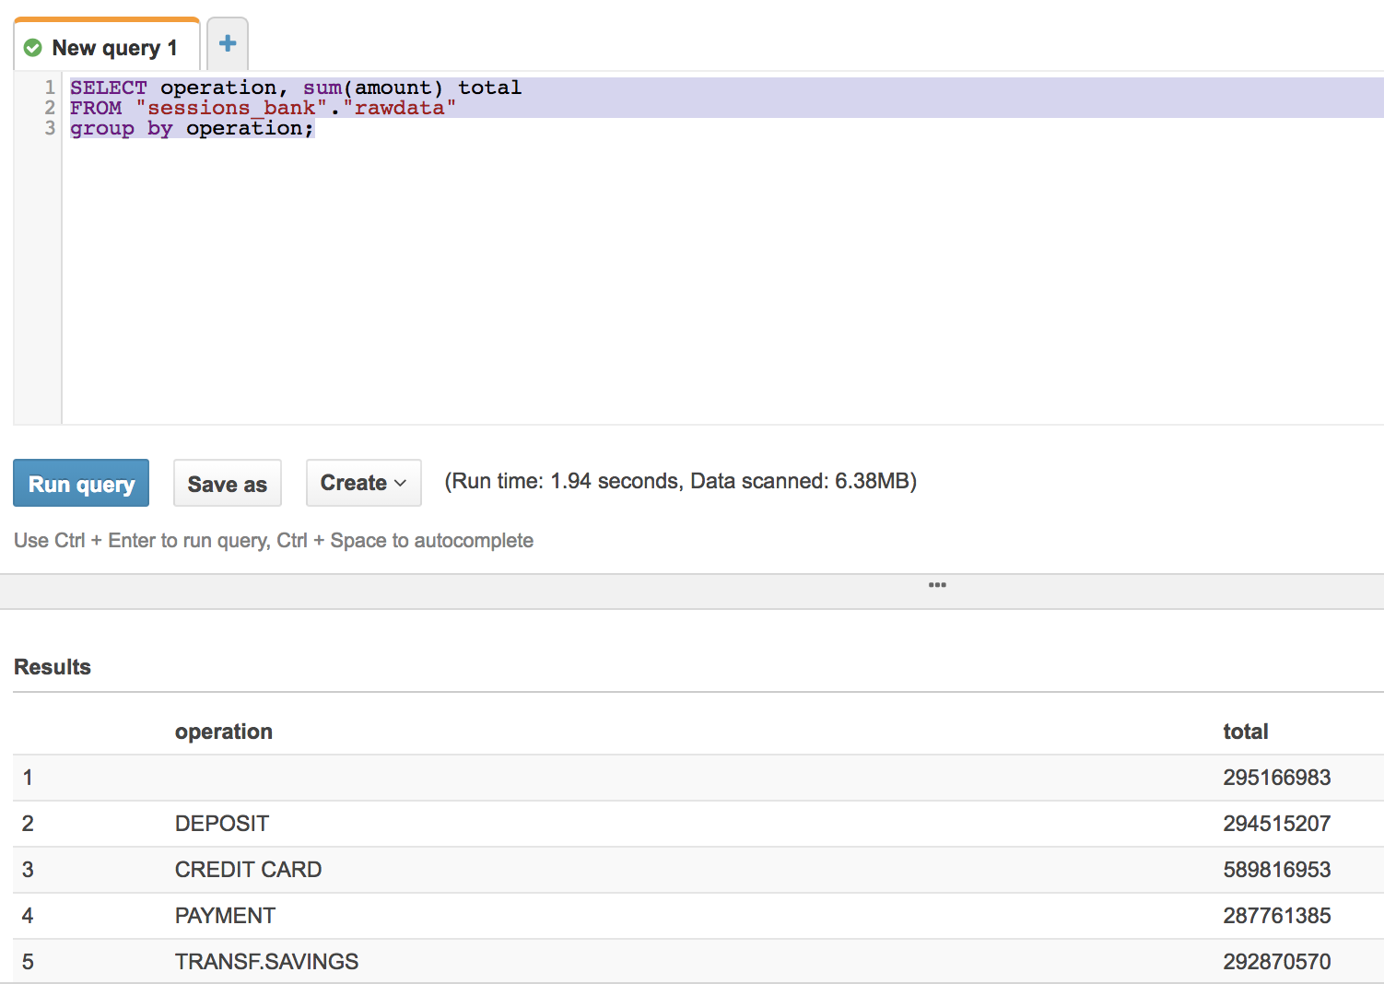

## Adjust Column names on Glue for aggregated Data

Go to the Glue console, Tables: aggregated, Database sessions_bank.

<https://console.aws.amazon.com/glue/home?region=us-east-1#table:name=aggregated;namespace=sessions_bank>



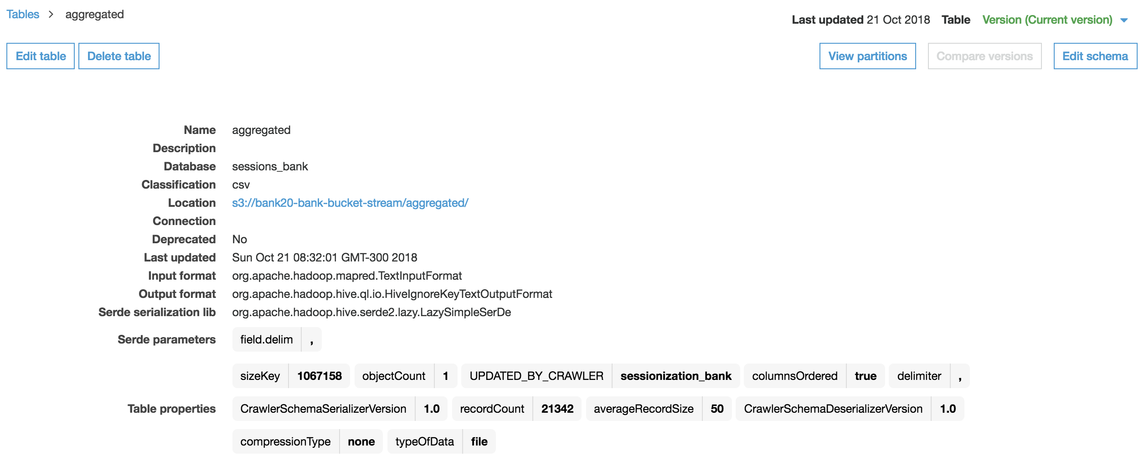

Click on **Edit Schema** to change column names.

**Change column names :**

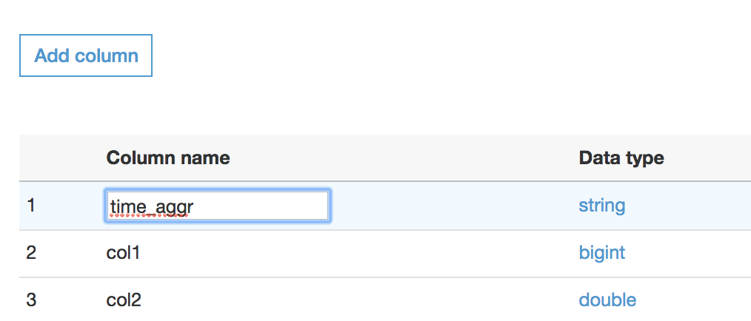

|  |  |
| --- | --- |
| **Current Value** | **Change to** |
| col0 | time_aggr |
| col1 | accountid |
| col2 | min_trans |
| col3 | max_trans |
| col4 | avg_trans |
| partition_0 | year |
| partition_1 | month |
| partition_2 | day |
| partition_3 | hour |

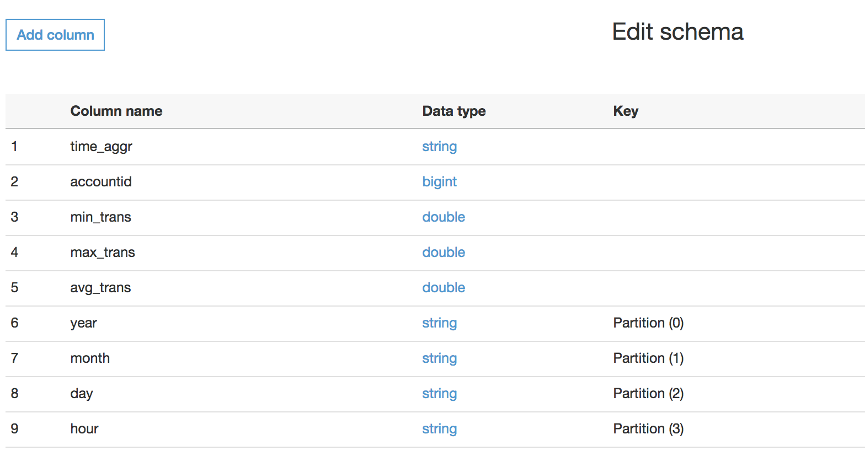

Then save:

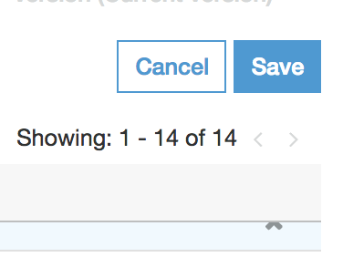

## Query aggregated data table in Amazon Athena

<https://console.aws.amazon.com/athena/home?region=us-east-1#query>

Go to the Athena menu and click on Databases, choose **sessions_bank_ .**

Execute the SQL:

SELECT accountid, count(1) transcs, max(max_trans)

FROM "sessions_bank"."aggregated"

group by accountid

order by transcs desc;

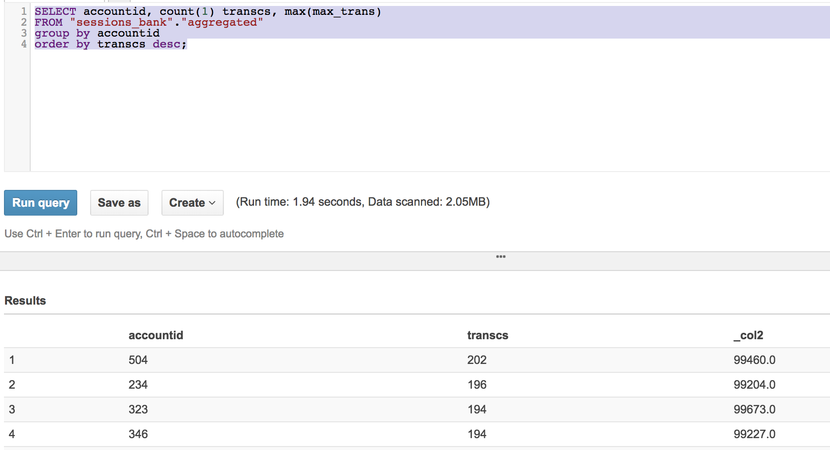

# Visualize Data with Amazon Quicksight

Go to Amazon Quicksight console.

<https://quicksight.aws.amazon.com/sn/start>



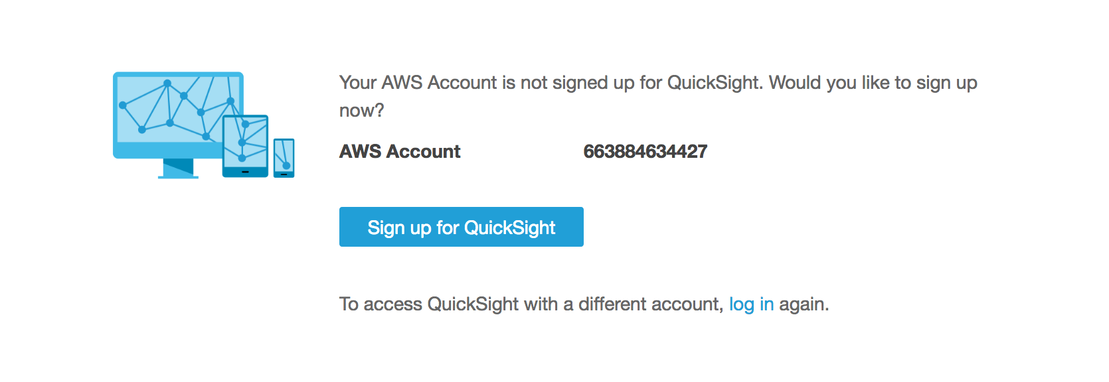

Click Sign up for QuickSight

Choose Enterprise for the QuickSight.

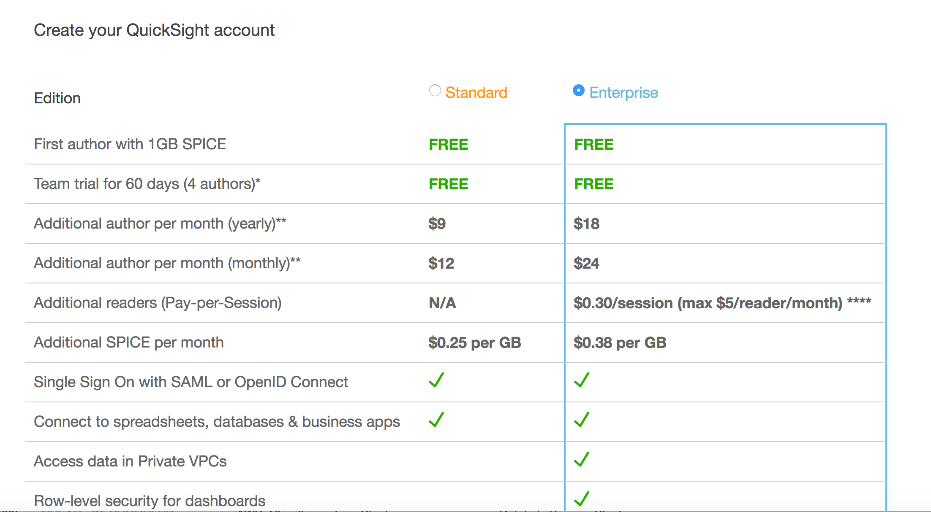

## Setup permissions to access Athena and S3

Create a name for Quicksigh account and put your email for Quicksigh administration :

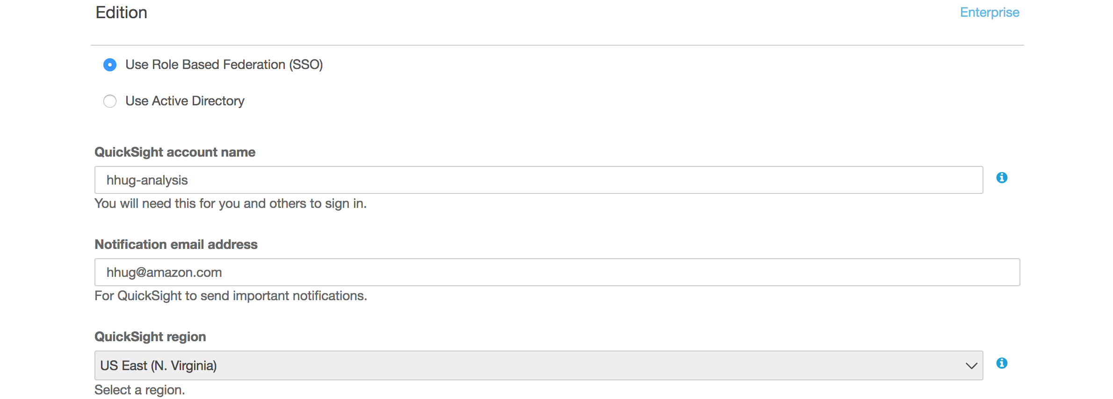

Account Name : yourname-analysis

Email : your email

Amazon S3 to Choose Buckets

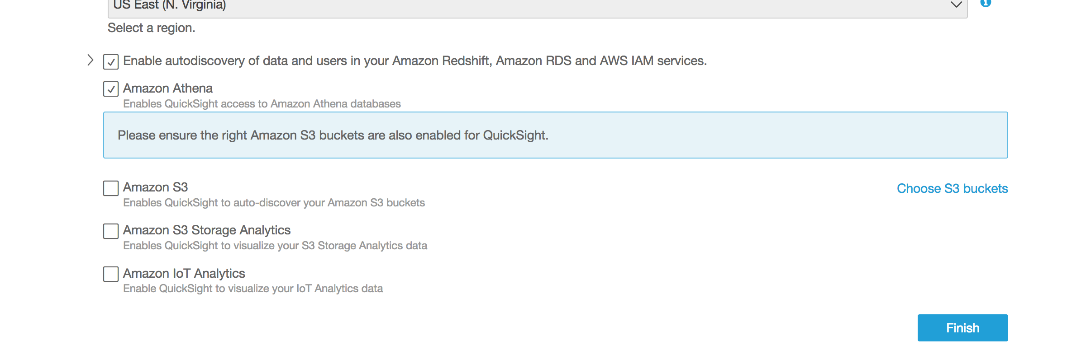

Mark Amazon S3 and Choose your S3 Buckets:

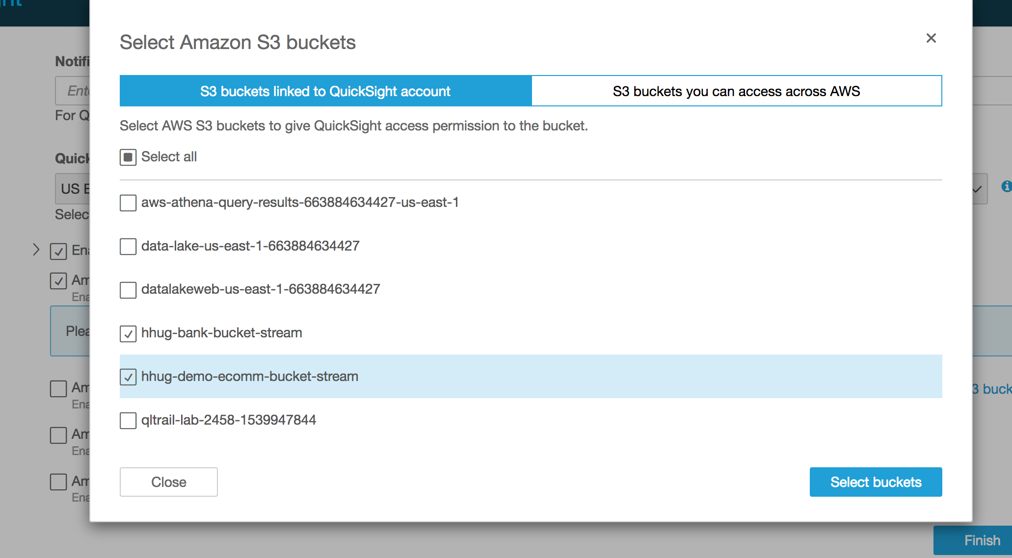

Then click Finish:



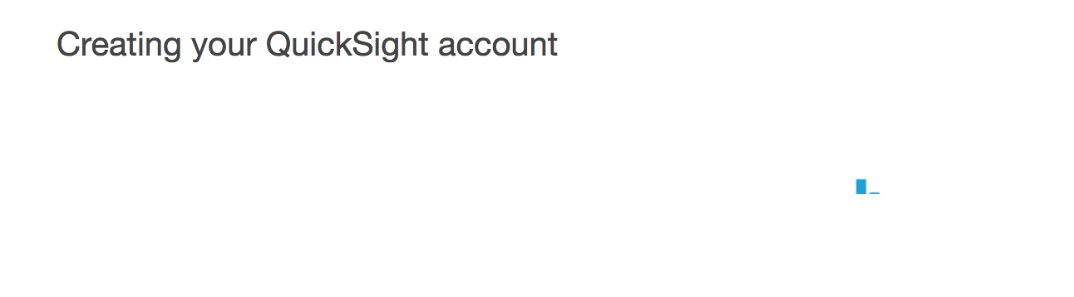

## Create a Data Source

Choose manage Data :

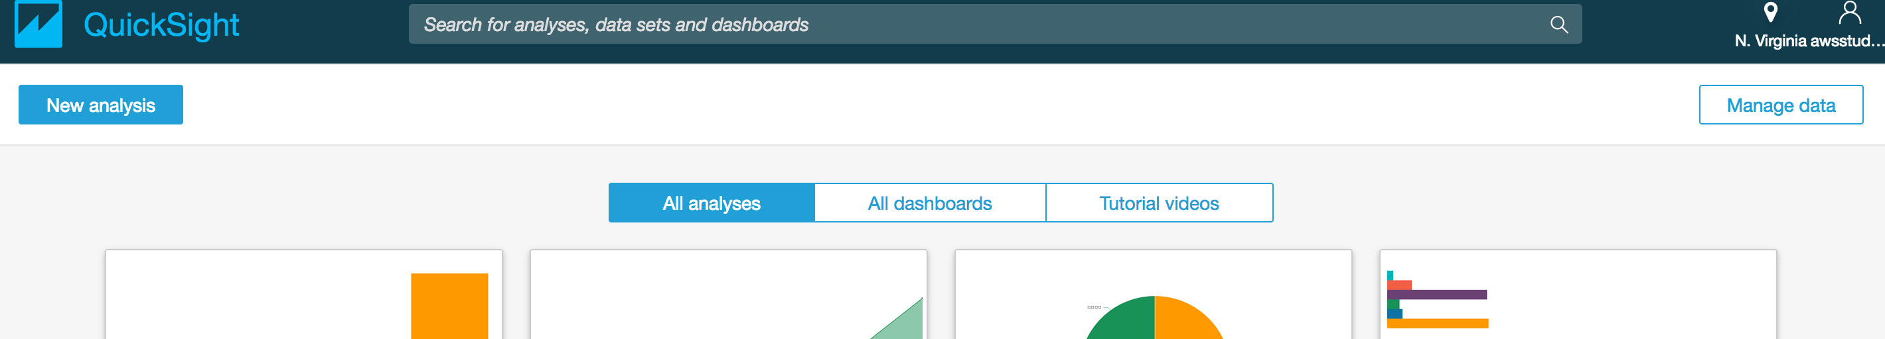

Click Manage Data.

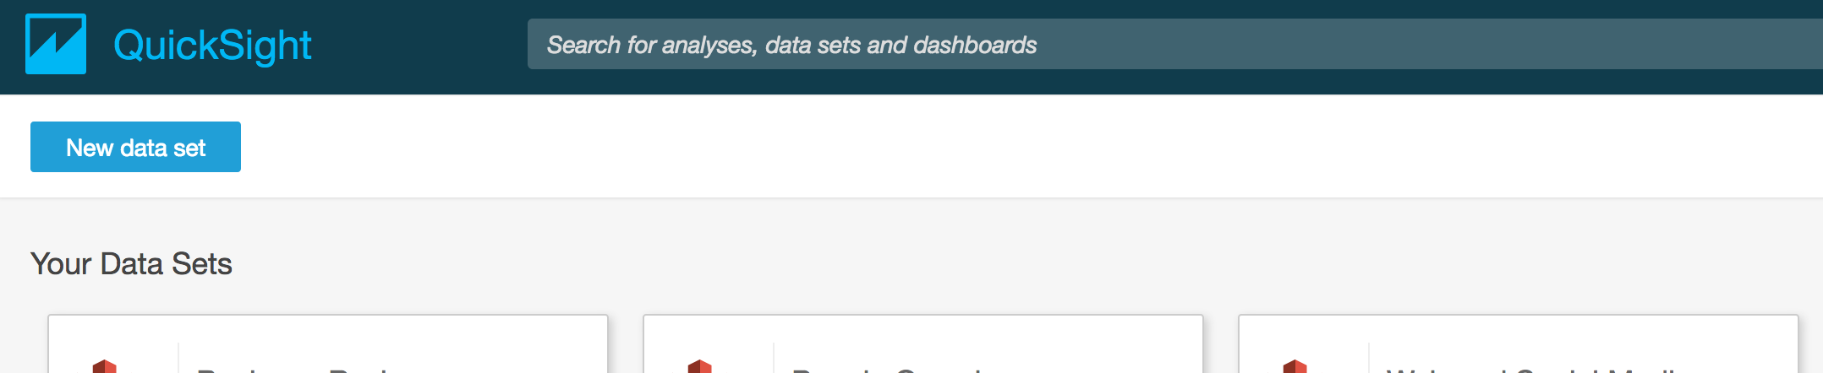

Select New data Set!

Pick Athena as Data Source :

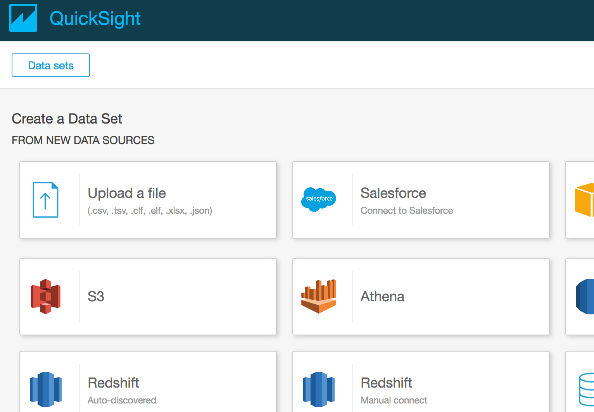

Data Source Name: bank

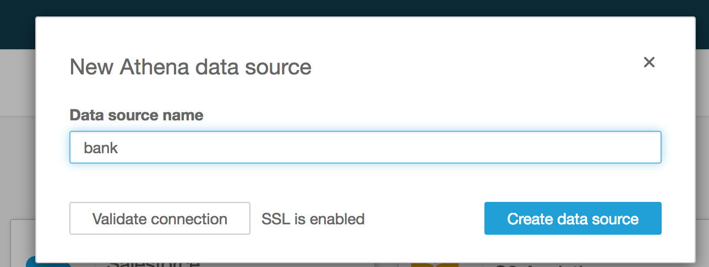

Pick the rawData Table

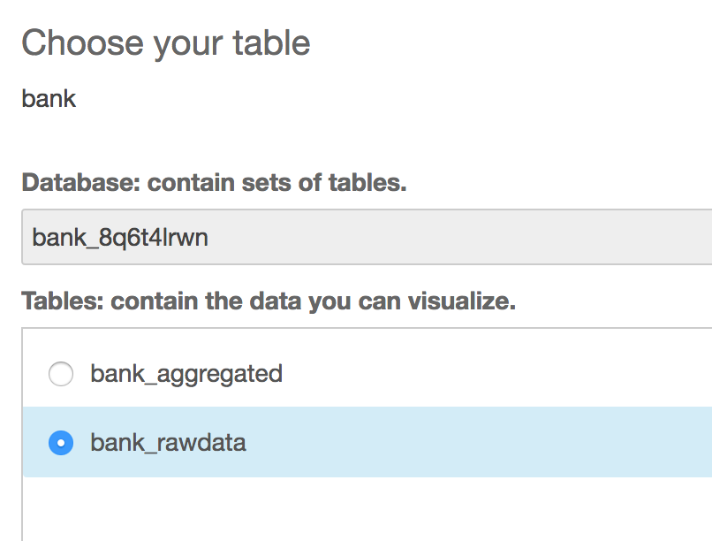

Import into Spice

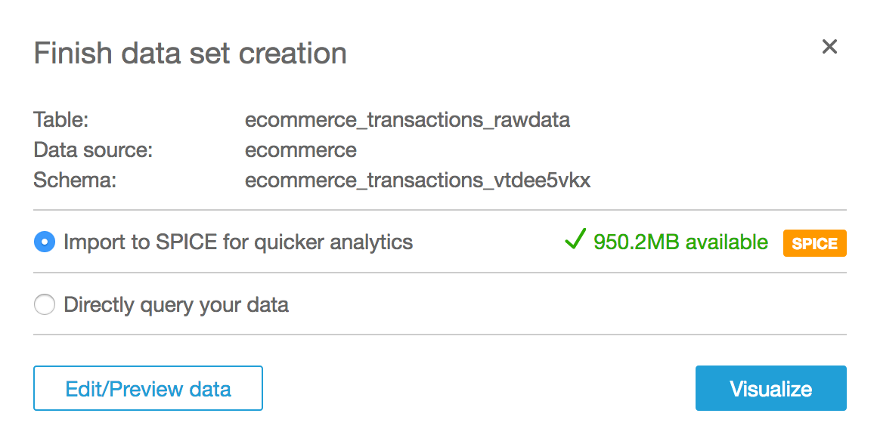

Then Visualize .

It will load the

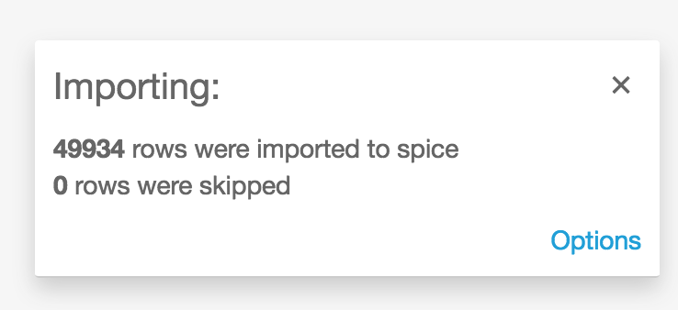

Click on Operation Field

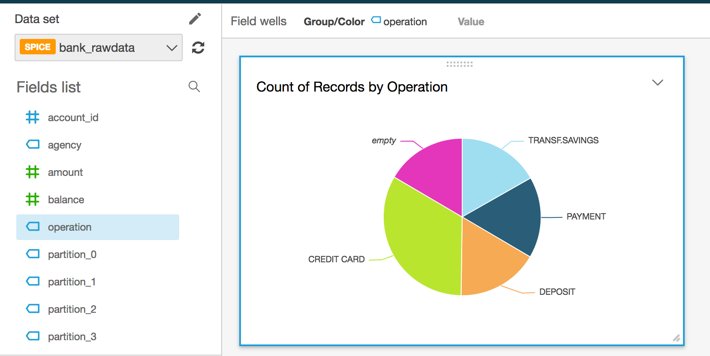

Click Add to Add a new visualization

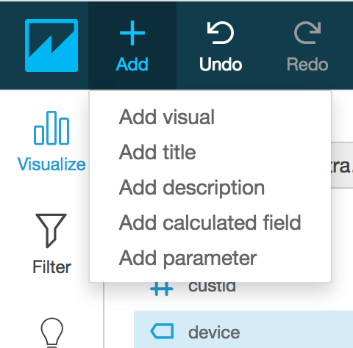

Choose the Heat Map graph type

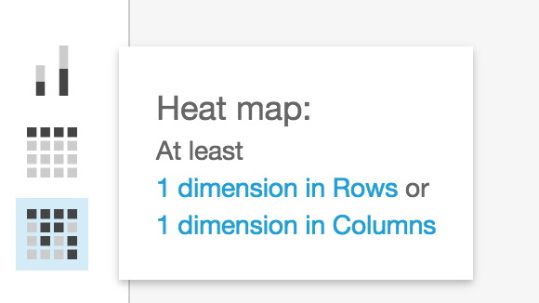

Choose first dimension operation

Second dimension type

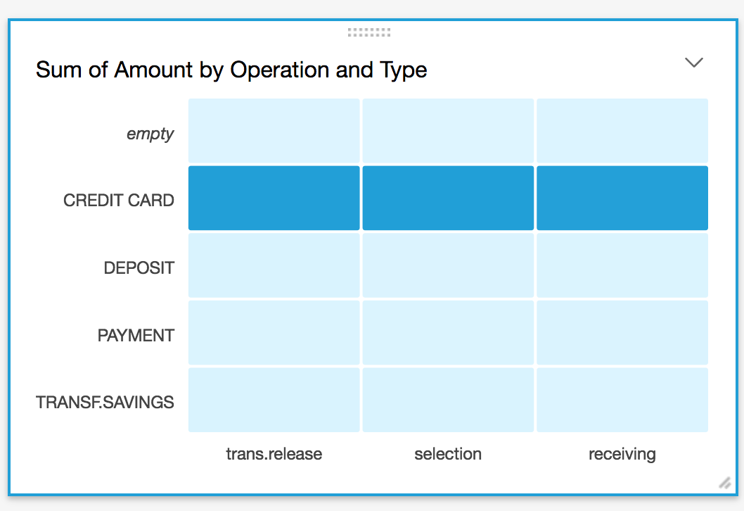

Save a Dashboard

Click on Share

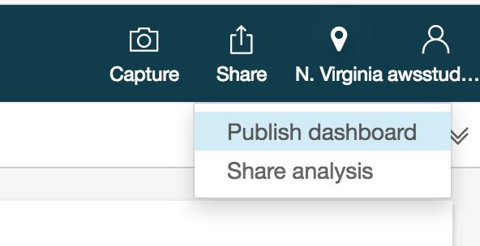

Publish Dashboard

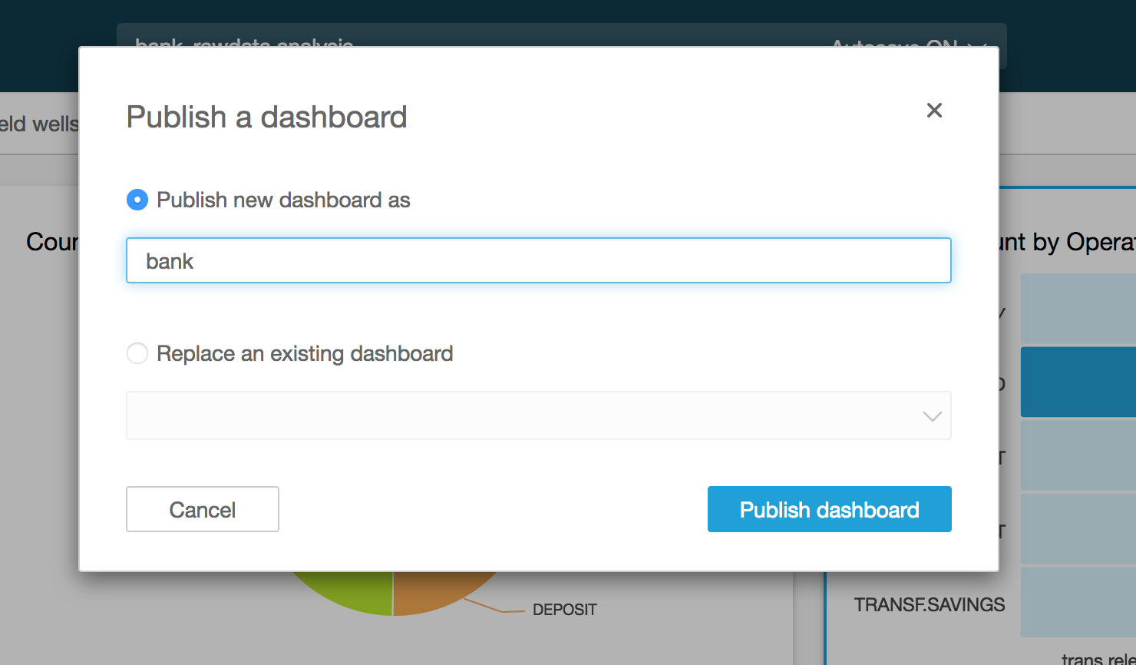

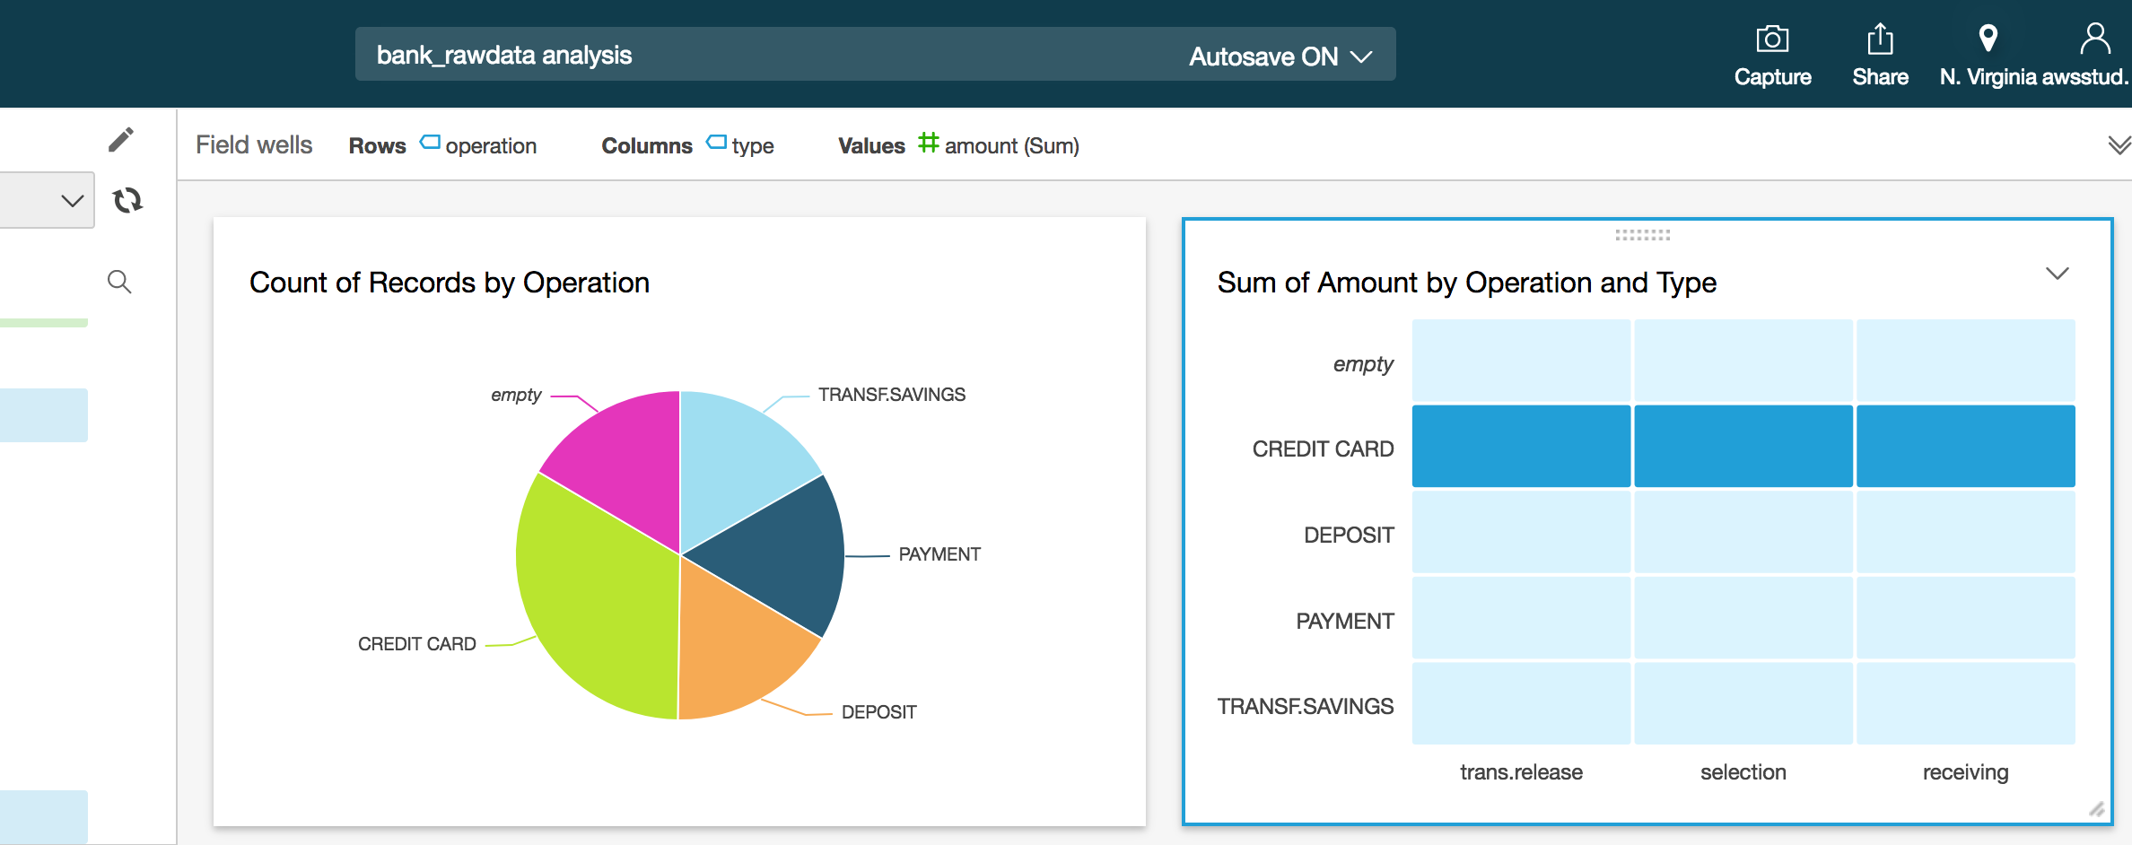

# (OPTIONAL) Tranforming Data – Amazon Glue

AWS Glue is a fully managed extract, transform, and load (ETL) service that makes it easy for customers to prepare and load their data for analytics. You can create and run an ETL job with a few clicks in the AWS Management Console. You simply point AWS Glue to your data stored on AWS, and AWS Glue discovers your data and stores the associated metadata (e.g. table definition and schema) in the AWS Glue Data Catalog. Once cataloged, your data is immediately searchable, queryable, and available for ETL. AWS Glue generates the code to execute your data transformations and data loading processes.



## Create a Tranforming Job in Glue

Go to Glue Jobs console:

<https://console.aws.amazon.com/glue/home?region=us-east-1#etl:tab=jobs>

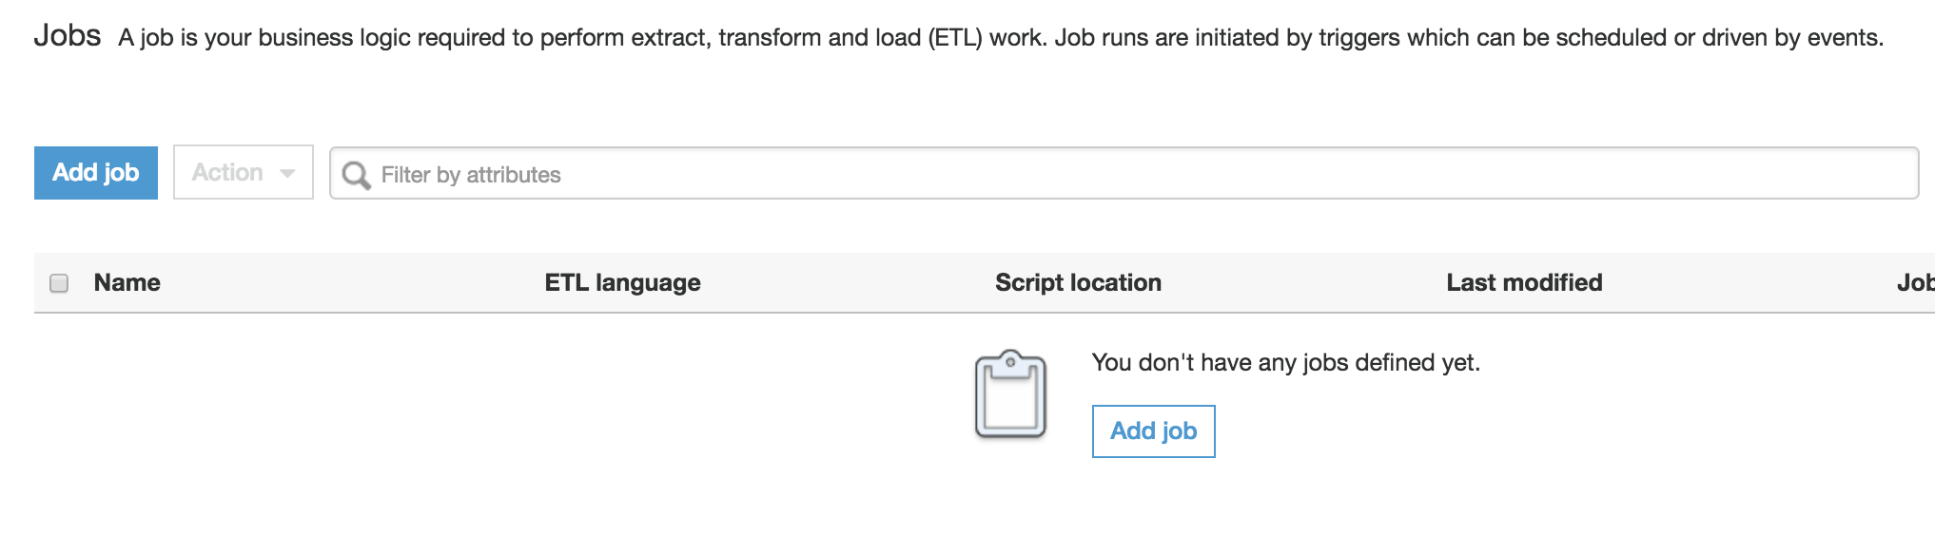

Add job

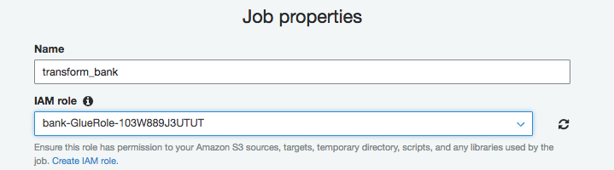

Choose bank role :

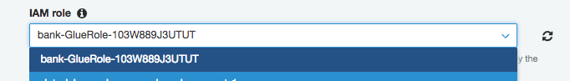

Let default and Choose between Scala or Python code

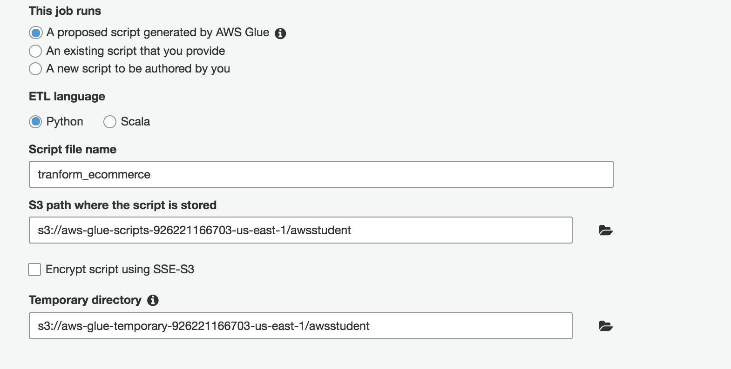

Pick the RAW table as our Source



Choose **Create Table** in your data target, Data store = **S3** , Format = **Parquet**, Target path = <<your bucket **>> /optimized**

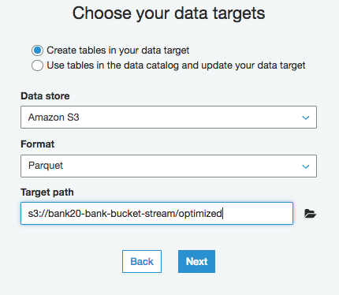

Let the Map as original

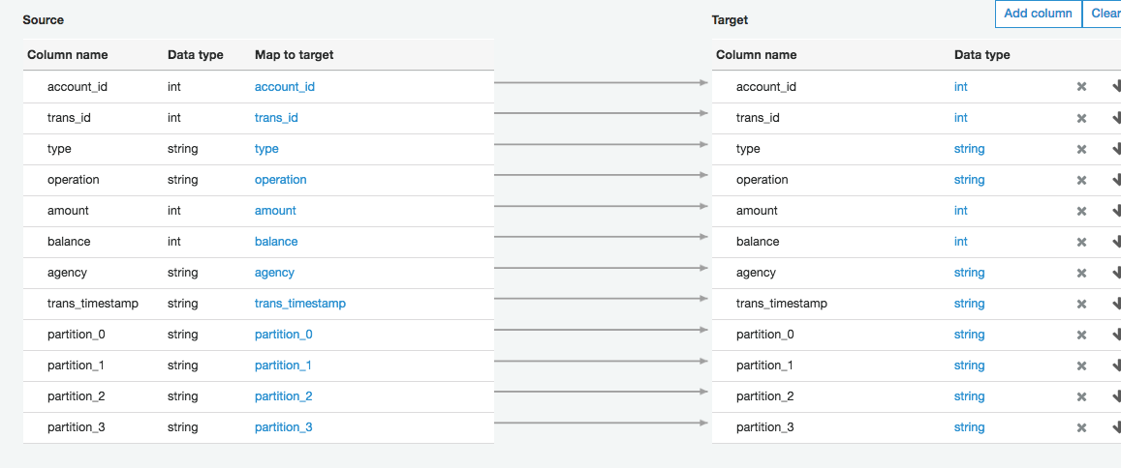

Next

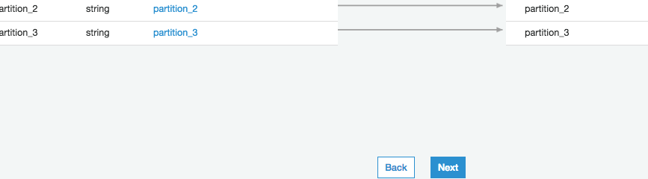

Save Job and edit script

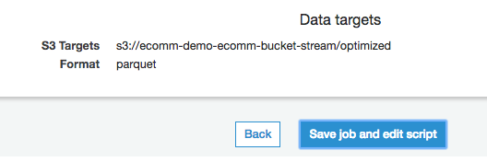

Examine the script :

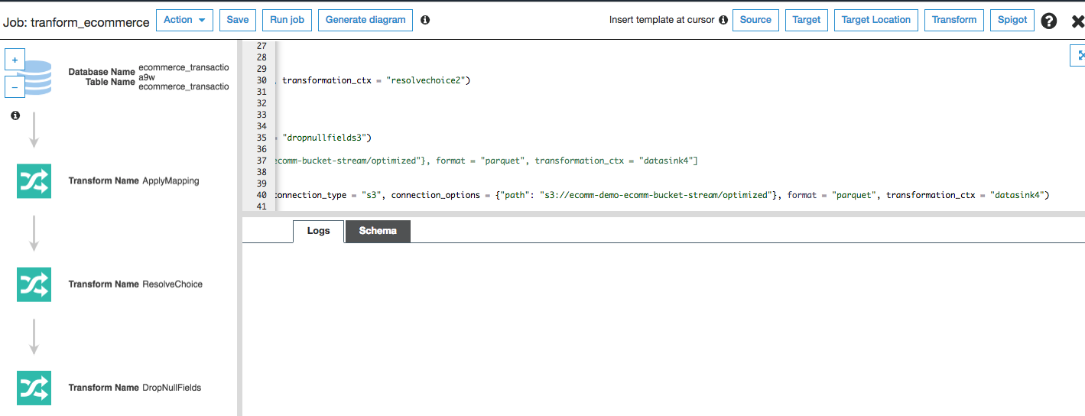

Click Run Job from the top menu

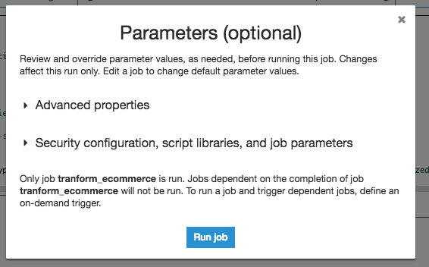

Wait for the job to complete

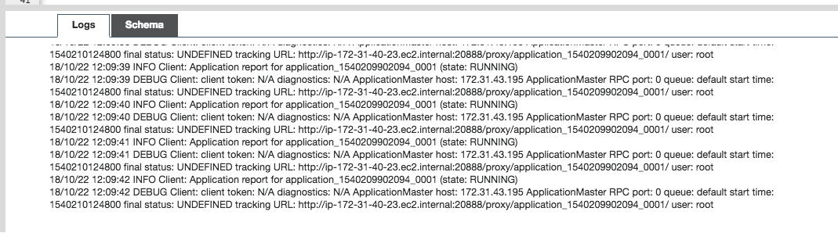

## Crawler the S3 to pick table the new table definition on Glue

<https://console.aws.amazon.com/glue/home?region=us-east-1#catalog:tab=crawlers>

Go to the Glue menu and click on Crawler, choose **bank_transaction….**

Mark the job and click Run crawler.

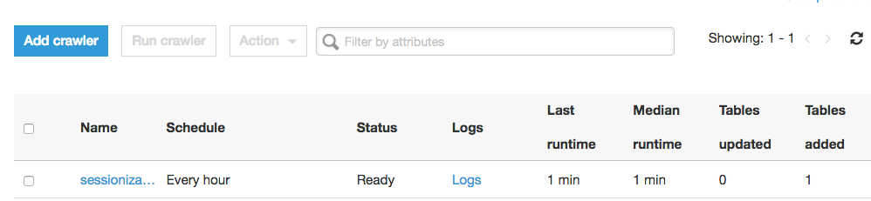

Mark the JOB and click Run crawler

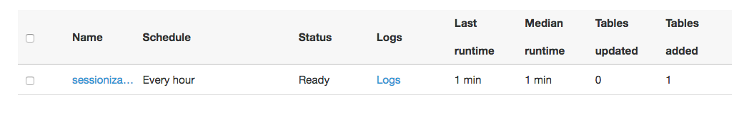

After the completion of the job you should see 1 Table added.

## Go to Athena to query the Optimized Table you created

<https://us-east-1.console.aws.amazon.com/athena/home?region=us-east-1#query>

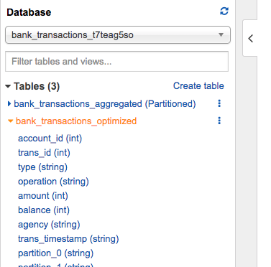

Preview the tables:

